Virtual Intelligence Service (VIS) TTP

**Purpose:**

The intention with this document is to provide volunteers in the 132nd VIS role the necessary background and information about the way VIS works in a 132nd context. In addition, the document will help campaign designers/mission makers understand how VIS can be used, and what products are needed from campaign designers/mission makers if they want to use a player staffed by VIS for the campaign.

**Disclaimer:**

The terms and processes described in this document is drawn from real world references but are simplified and adjusted to meet the need for conducting a campaign in DCS.

**How to read:**

Chapter 1 is an introduction that first explains the various roles that are used in a campaign. Then it gives av explanation of the various products that can be encountered and how they are connected. Chapter 1 ends with some general concepts for a full campaign using the VIS and JFACC construct before it finishes with giving an understanding of various VIS ambitions.

Chapter 2 is a theoretical chapter introducing what is intelligence and the intelligence cycle and is a foundation for the coming chapters.

Chapter 3 goes into detail in the VIS Air Campaign Planning explaining the Intelligence Preparation of the Battlefield (IPB) process and giving an understanding of targeting. This is the process that is conducted prior to the first mission is executed in the campaign. Chapter 4 goes into detail in the process for VIS in the execution of the campaign

Chapter 5: contains a condensed step by step procedure for VIS for planning and executing the air campaign (In line with the details described in chapter 3 and 4). The idea is that VIS volunteers can follow the steps in chapter 5, but can look up details as necessary in chapter 3 and 4)

# Chapter 1: Introduction

A full campaign that uses volunteers in the role of Joint Force Air Component Command (JFACC) and Virtual Intelligence Service (VIS) is very complex and consists of many various actors/roles and many various documents to support the campaign, the planning, and its execution. Chapter 1 will introduce the various roles that are encountered in the full campaign, it will explain the various products encountered during the campaign, and it will lay out some general concepts for the execution of the campaign.

## Roles/actors

### Joint Force Commander (JFC) (Mission Designer)

JFC is the commander of a Joint Task Force or a Combined Joint Task Force. JFC will provide the overall guidance and mission to all components (land, sea, air, and special operations).

### Joint Force Air Component Command (JFACC) (Player volunteers)

Joint Force Air Component Command (JFACC) is the headquarter of the Joint Air Forces in the operation (Both Navy and Air Force, so for us in the 132nd hosted campaigns; all air forces)

JFACC plans and executes air campaigns. JFACC have a role both in campaign planning for a campaign, but also for the planning for each ATO day (each event)

The JFACC role is about giving the direction and guidance for air operations. JFACC will publish its guidance before each event in the Air Operations Directive (AOD), and this direction and guidance will be used by everyone involved, especially AWACS controllers and mission commanders/flight leads for planning packages or flights.

JFACC also holds responsibility as Airspace Controlling Authority (ACA) and Area Air Defense Commander (AADC) for any 132nd hosted campaign.

If needed JFACC may also request support from other component commands (Land, Sea and Special Operations,

### Virtual Intelligence Directorate (VID) (Mission Designer)

VID provides intelligence injects into the campaign. This can be considered a broader intelligence agency than VIS. VID is the way the mission designer can inject relevant or irrelevant information into the campaign, that can be picked up by VIS and JFACC and used for the execution of subsequent events based on the new information.

### Virtual Intelligence Service (VIS) (Player volunteers)

The VIS role is about providing intelligence for the rest of the organization. The individuals functioning as VIS will try to make sense of the battlefield based on the reports from pilots after events, in addition to intelligence from VID.

VIS has a dual purpose:

1. Support the event planning on a higher level (support to JFACC)
2. Support the event planning on a tactical execution level (support to pilots)

### Land Component Command (LCC) (Mission Designer)

This is the land component of the Joint Force and controls the fight taking place on the ground. The land forces are slow to maneuver but are often the decisive factor. MCC and JFACC will often have a supporting role to help LCC reach their objectives.

### Maritime Component Command (MCC) (Mission Designer)

This is the maritime component of the Joint Force, consisting of surface ships, submarines. Naval aviation is for the 132nd purposes controlled by JFACC. Surface ships operating together may form a Surface Action Group (SAG) with mutual support. MCC may have several SAG`s. Maritime units are fewer in number than land units, and can easily be task organized in various SAG formations based on the need for the specific mission.

### Special Operations Component Command (SOCC) (Mission Designer)

This is the special operations component of the Joint Task Force. Special operations can be used for sensitive missions, or demanding missions that LCC is not suited for. Typical insertions deep behind the enemy line to provide intelligence, or to support attacks by JTACs.

## Products

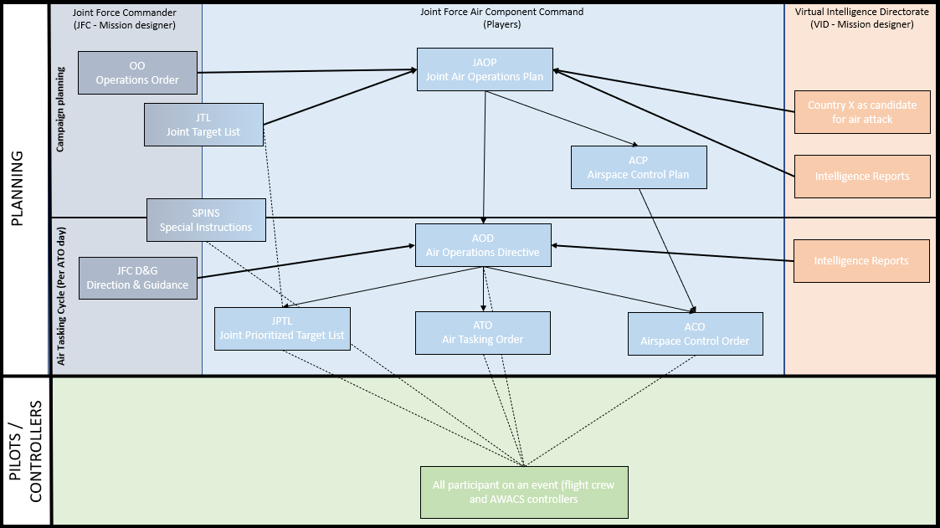

Figure Campaign products

### Air Campaign Planning Products:

Air campaign planning products are provided or created prior to the first event in a campaign:

#### Operation Order (Created by mission designer)

The operation order is the overall order from the Joint Force Commander (JFC). It will contain an overall situation, an overview of friendly and enemy forces. It will also contain the mission and the commander’s intent with the operation. Furthermore, the operation order contains a broad concept of operation and objectives to be met. The operation order will also list specific tasks to the component commands (Land, Air, Sea, Special operations).

Target audience for the operation order is **JFACC and VIS**.

#### Country X as Candidate for Air Attack (Created by mission designer)

The candidate for air attack study is provided by the mission designer to VIS and JFACC to be used in planning and execution of the campaign. The attack study contains a lot of information about the enemy’s system for use in targeting and development of additional intelligence.

Target audience for Candidate for Air Attack Study is **VIS and JFACC**.

#### Joint Target List (JTL) (Created by mission designer)

The Joint Target List is a master list of available targets to be attacked during the air campaign. The effects of attacking the various targets vary, but all targets on the Joint Target List is targets that may influence the progress in the campaign. The Joint Target List is created by VID and provided to VIS/JFACC when VIS/JFACC starts planning the air campaign.

Target audience for the JTL is **VIS and JFACC**.

#### Special Instructions (SPINS) (Created by mission designer and JFACC)

This is a document used for mission designer and JFACC to provide important information for the campaign and its execution. SPINS are to be read by all pilots and controllers participating on an event.

Target audience for the SPINS is **Everyone** involved in the campaign.

#### Joint Air Operations Plan (JAOP) (Created by JFACC)

The JAOP is JFACC`s overall plan on how to conduct the campaign. The JAOP will have the mission for JFACC together with JFACC’s intent and the objectives for JFACC. It will contain the concept of operation through information of what is planned to be conducted during the various phases in the operations. The phases may be given in the Operations Order, but JFACC can add new phases or break down the phases in various sub phases. The JAOP will also include a timeline over the various phases and sub phases. The JAOP is created prior to the first event and will be the guiding document for further events.

Target audience for the JAOP is **Mission designer** + **aircrew, JTACs and controllers** (to get the big picture)

#### Airspace Control Plan (ACP) (Created by JFACC)

As part of the air campaign planning, JFACC with its responsibility as Airspace Control Authority (ACA) create an Airspace Control Plan that contain all necessary regulations for the use of the airspace during the campaign. The ACP includes transit corridors, routes, navigation points, contact points, initial points, kill boxes, minimum risk routes, fighter areas of responsibility, missile engagement zones. Points/areas in the ACP are used as basis for the creation of the Airspace Control Order (ACO) that supports each Air Tasking Order (ATO).

Target audience for the ACP is **Mission designer + JFACC during execution**.

### Air Tasking Cycle Products:

Air tasking cycle products are provided or created for each ATO day or event in a campaign:

#### Joint Force Commander Direction & Guidance (JFC D&G) (Created by mission designer)

When necessary (before an event or a new phase), JFC may see it necessary to provide additional direction and guidance for the overall campaign. This will be published in the JFC D&G document.

Target audience for the JFC D&G is **JFACC and VIS**.

#### Air Directions Directive (AOD) (Created by JFACC)

During the execution of the air campaign JFACC uses the AOD to guide and influence operations and taskings. The AOD is JFACC’s broad plan and guidance for the execution of an ATO day or phase. The AOD is an important document as it contains the necessary directions and guidance for AWACS controllers to act in accordance with JFACC intent.

Target audience for the AOD is **Mission designer, AWACS controllers, JFACC** (for breaking it down into the ATO) **and all aircrew flying on that ATO day** to get the situational awareness of the situation for that ATO day or that phase.

#### Air Tasking Order (ATO) (Created by JFACC)

During the execution of the air campaign, the ATO is used daily by JFACC to give detailed taskings to flights and squadrons. The ATO gives information about the mission for each flight that are to be flown that ATO day.

Target audience for the ATO is **Mission designer,** **Aircrew, JTACs and controllers** that are participating on the event for that ATO.

#### Airspace Control Order (ACO) (Created by JFACC)

The ATO is supported by the ACO which provide the detailed information regarding the planned use of the airspace for the specific ATO day. The ACO activates already planned points/areas on the Airspace Control Plan (ACP).

Target audience for the ACO is **AWACS controllers, JTACs and aircrew** (for flight planning and preparation)

#### Joint Prioritized Target List (JPTL) (Created by JFACC)

The Joint Prioritized Target List (JPTL) is a list of planned targets to be attacked for a specific ATO day. JPTL are added as an annex to the AOD.

Target audience for the JPTL is **AWACS controllers, JTACs + aircrew flying that** event to get a better situational awareness.

### Other products

In addition to the products mentioned in the previous section, other products may also be encountered during a campaign:

#### Intelligence reports (Created by mission designer or VIS)

VID and VIS (if participating in the campaign) will publish intelligence reports which gives updates to the enemy situation. This is something JFACC need to bring into its planning and decide if they need to change their plans or change their priorities.

#### Concept of operations (CONOP) (Created by mission designer)

From time to time the other components (Ground, Sea, SOF) may provide a concept of their operations. This is provided so JFACC gets a better understanding of the other friendly operations planned. JFACC can then better figure out they can support the other components. A Concept of operation can also be provided by JFACC for approval by JFC for a specific sensitive operation as ordered by Joint Force Commander (JFC).

## General concepts

When using JFACC and VIS construct in 132nd hosted events the following guiding principles are effective:

* One ATO Day is divided into several events.
  + This is decided between mission designer and JFACC/VIS volunteers
  + Typically, one ATO day consist of minimum 2 events
  + The benefit this gives is that the products created for an event is still valid also for the next event and thus, events can be conducted at a more rapid pace. The only artificiality is that for event number two, JFACC will need to create a new ATO to facilitate for the signups on the actual date. But other products such as AOD, JPTL, ACO is still valid with the same information. For each ATO day JFACC/  
    VIS will be informed prior to planning that ATO day how many events the ATO day is divided into, and what time windows the events will cover (day and/or night).
* ATO day in a campaign is given the name D1 (for first day of campaign), D2 (second day), etc.
  + If more events are conducted on the same ATO day, then the event number for the day is added:
    - ATO Day 1, event 1: D1.1.
    - ATO Day 1, event 2: D1.2
    - ATO Day 2, event 3: D2.3.

## VIS Ambitions

VIS participation in a campaign can have three different ambition levels:

### VIS Ambition 1

VIS ambition 1 is the most ambitious. This alternative includes full participation from VIS in both planning the campaign and during execution. In this alternative VIS will support both JFACC and pilots/controllers in their preparation and planning for the events.

See section 4.1 and section 4.2 for best practice on how to organize VIS.

### VIS Ambition 2

VIS ambition 2 is the middle ambition for VIS. This alternative includes full participation from VIS in the execution of the campaign only, and no VIS participation in the campaign planning. VIS will in this alternative support both JFACC and pilots/controllers in their preparation and planning for events.

See section 4.1 and section 4.2 for best practice on how to organize VIS.

### VIS Ambition 3

VIS ambition 3 is the lowest ambition for VIS. This alternative includes only support to pilots in execution of the event. VIS will in this ambition only focus on enemy air threat and SAM’s that are threats to pilots.

See section 4.1 and section 4.2 for best practice on how to organize VIS.

# Chapter 2: Theory

## Intelligence

Intelligence strives to provide accurate, timely, and relevant knowledge about the enemy (or potential enemy) and the surrounding environment. In other words, the primary objective of intelligence is to support decision-making by reducing uncertainty about the hostile situation to a reasonable level—recognizing, of course, that the fog of war renders anything close to absolute certainty impossible. In achieving its primary objective, intelligence performs three related tasks:

* First, it identifies and evaluates existing conditions and enemy capabilities.
* Second, based upon those existing conditions and capabilities, it estimates possible enemy courses of action, providing insight into possible future actions.
* Finally, intelligence assists in the development and evaluation of friendly courses of action based on the results of the first two tasks.

### Information

**Information as a Resource.** Information is one of the most precious resources available to any decision maker (JFACC, JTAC, aircrew or controller). By nature, humans are information processors who seek knowledge of the past, present, and prospects for the future. Without valid information, decision makers have no logical basis for choosing one course of action over another. Increasing information generally decreases uncertainty in decision making, up to a point of diminishing returns, where too much information can confuse a situation. In a sense, information is like fire insurance. It has little value until it is needed, but then it is invaluable.

**Sources of Information.** Information can take many forms and be derived from many sources. Information can result from observing or reporting an event. It can also result from opinions, judgments, and interpretations by participants. Information may be objective or subjective.

**Characteristics of Information.** Information has many characteristics and does not come without cost. Acquiring sufficient, accurate, and timely information can be very expensive. It can be perishable and is generally imperfect. Consequently, information from one source should be verified with another source whenever possible. Frequently, information derived from one source can be used as a cue in researching other sources or in collecting additional or different information.

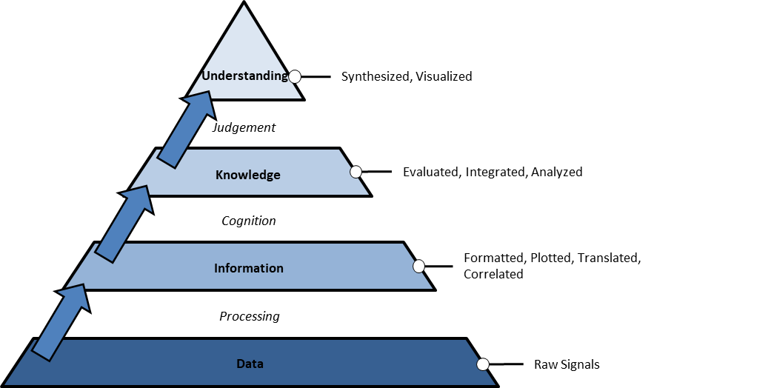

Figure Information Hierarchy

### Intelligence

The overall objective of intelligence is to enable commanders and combat forces to “know the enemy” and operate smarter. It helps commanders by collecting, analyzing, fusing, tailoring, and disseminating intelligence to the right place at the right time for key decision making. Intelligence provides indications of enemy intentions and guides decisions on how, when, and where to engage enemy forces to achieve the commander’s objectives. It assists in combat assessment through battle-damage assessment

**Intelligence Processing**. Since information does not present itself for exploitation, it must be sought, gathered, assembled, and processed into usable form. The outcome is the transformation of raw information into intelligence suitable for making valid decisions and conducting missions. Intelligence is required for both planning campaigns (JFACC) and for planning and conducting tactical operations (JFACC, JTACs, aircrew and controllers).

Intelligence sources are the means or systems used to observe, sense and record, or convey information. There are six primary intelligence source types: imagery, human, signals, measurement and signature, open source, technical.

Intelligence organizations integrate technical and quantitative assessments with analytical judgments based on detailed knowledge of the way the enemy thinks and operates. Intelligence personnel should maintain an independent perspective. Consumers of intelligence anticipate that even the best intelligence may not provide a complete picture, especially when the enemy is practicing deception or when the intelligence is derived from a single source. Still, intelligence gives commanders the best available estimate of enemy capabilities, Centers Of Gravity’s (COGs), and Courses Of Action (COA).

### Intelligence Cycle Overview

Intelligence provides clear, brief, relevant, and timely analysis on enemy capabilities and intentions for planning and conducting military operations. The intelligence community uses the intelligence cycle which is broken down into five separate categories or steps.

The intelligence cycle is defined as: “the steps by which information is converted into intelligence and made available to users”. The five steps in the cycle are:

* **Planning and direction**: determination of intelligence requirements, preparation of a collection plan, issuance of orders and requests to information collection agencies.
* **Collection:** acquisition of information and the provision of this information to processing and/or production elements.
* **Processing:** conversion of collected information into a form suitable to the production of intelligence.
* **Production**: conversion of information into intelligence through the integration, analysis, evaluation, and interpretation of all source data and the preparation of intelligence products in support of known or anticipated user requirements.
* **Dissemination**: conveyance of intelligence to users in a suitable form.

#### Planning and direction

The first phase in the intelligence cycle is planning and direction. This phase consists of the identification of intelligence requirements and the planning of intelligence operations and activities to satisfy those requirements. JFACC directs the intelligence effort; VIS manages this effort for JFACC. In so doing, VIS is guided by the JFACC's intent, the established priority intelligence requirements, and specific guidance provided by JFACC for the conduct of the intelligence effort.

#### Collection

Collection is the second phase of the intelligence cycle. During collection intelligence sources (aircrew, JTACs, AWACS controllers) collect and deliver information to VIS in After Action Reports or Inflight reports. Effective collection depends upon the use of a variety of mutually reinforcing sources (For example satellite imagery, ground force observation post, intelligence collection flights (using TGP, RWR or ELINT pods). Necessary, planned redundancy and overlap of sources increase the reliability of information and can reduce the effectiveness of enemy deception or denial efforts.

#### Processing and exploitation

Processing and exploitation are the third phase of the intelligence cycle, the conversion of raw data into a form suitable to produce intelligence. Largely a technical function, processing and exploitation converts the data into an understandable form and enhances its presentation (For example taking coordinates of observations and making it available on a map).

For VIS this mean to take observations or information from reports and register it in an intelligence log, so the information is readily available for intelligence production. In addition, observations or information also need to be plotted on a map to be able to be used in a meaningful way during the production of intelligence.

#### Production

The fourth phase of the intelligence cycle is production, the activities by which processed data (in the intelligence log and received intelligence reports) is converted into intelligence. Production involves evaluating reliability, and accuracy of information. It involves analyzing information to isolate significant elements. It includes integrating all relevant information to combine and compare those elements of information with other known information.

Finally, production involves interpreting the information to form logical conclusions that bear on the situation and that support the commander's plan to engage the enemy.

Production is a process of synthesis—the most important action in developing usable intelligence for the commander. Production arranges the intelligence pieces to form coherent images. It is this step which adds meaning to these pieces, creating knowledge. Synthesis does not generally create a complete image—totally filling in the gaps and eliminating uncertainty— but it should provide an image from which the commander can reach an acceptable level of understanding. In the end, synthesis answers the all-important question: "*What effect does all of this have on our ability to accomplish the mission?"*

#### Dissemination

The fifth phase of the intelligence cycle is dissemination, the timely conveyance of intelligence in an appropriate form and by a suitable means to those who need it (JFACC, aircrew and controllers). Depending on its importance and time-sensitivity, intelligence may be disseminated—" pushed"——directly to users, or it can be sent to a web page from which users can "pull" that intelligence which they need. Intelligence flows by any number of channels or methods.

No one phase of the intelligence cycle is more important than the others—they are interdependent. Without proper direction, the other phases will be uncoordinated and ineffective. Without effective collection, there may be too much or too little information, and the information obtained may prove irrelevant. Without processing and production, the resulting mass of information may appear meaningless. Lengthening production time will delay dissemination. The first four phases of the intelligence cycle offer marginal value unless the intelligence arrives to the right person in time and in a useful form to support decision-making. Finally, intelligence operations are wasted if JFACC/JTACs/aircrew/controllers fail to understand and act upon the knowledge intelligence offers. For simplicity, the intelligence cycle is described as a sequential method; however, in practice, it is a dynamic process responsive to changes in the situation and the JFACC/JTACs/aircrew/controllers evolving intelligence needs.

## Targeting

Targeting is the process of selecting and prioritizing targets and matching the appropriate response while taking account of JFC/JFACC objectives, and capabilities. The targeting process identifies, selects, and exploits critical vulnerabilities within targeted systems to achieve the JFC/JFACC’ desired end state. It is not the exclusive province of one specialty or division, such as intelligence (VIS) or operations (JFACC), but blends the expertise of both JFACC and VIS.

A target is an entity or object considered for possible engagement. An entity can be defined as facilities, individuals, virtual (nontangible) things, equipment, or organizations. It is a fundamental tenet of targeting that no potential target derives its importance merely because it exists, or even that it is a crucial element within a target system. Any potential target derives its importance only by the extent to which it enables enemy capabilities and actions that must be affected to achieve objectives. Multiple actions may be taken against a single target, and actions may often be taken against multiple targets to achieve a single effect.

Targeting is focused on achieving objectives. During planning, objectives are translated into detailed actions against adversary targets that produce desired effects. Every target nominated should contribute to attaining JFC/JFACC objectives and the end state.

Target selection must also consider second- and third-order effects that may either positively or negatively contribute to campaign success.

In supporting the JFC/JFACC’s objectives, the targeting process is designed to achieve effects in a systematic manner. Targeting is rational and iterative. It methodically analyzes, prioritizes, and assigns forces and capabilities against enemy targets. Targeting is not mechanical and does not assume that the same actions always produce the same effects. If the desired effects are not achieved, targets may be re-planned for subsequent engagement, or different targets may be selected.

Targeting should not be separated from JFC/JFACC objectives. Otherwise, it becomes an inputs-based exercise in target servicing—simply matching available resources to those targets. Integrating targeting within the overarching planning processes (air campaign planning and air tasking cycle) enables an effects-based approach to operations (EBAO).

### The Targeting Process

The targeting process is a conceptual construct used to explain how targeting is performed. Though driven by intelligence (VIS), it is not the purview of any one community. Community boundaries are beginning to blur between operations (JFACC) and intelligence (VIS). The targeting process includes actions that produce target intelligence and target materials which are applied in support of operational decision making and the use of force.

This process includes the steps by which targets are recommended, and is comprised of six phases:

* Objectives and guidance derivation
* Target development
* Weaponeering
* Force application
* Execution planning
* Combat assessment

These phases are bi-directional and iterative. Often, they overlap and VIS/JFACC may perform several of them simultaneously.

#### Objectives and Guidance Derivation

Objectives and guidance derivation comprise the foundation of the targeting process, JFC/JFACC objectives establish priorities for targeting, damage criteria, and restrictions on force employment. Guidance may include principles of war, the international Law of Armed Conflict (LOAC), and established rules of engagement. Objective and guidance should be clear and unambiguous. The necessary first step as an individual working with targeting, is to understand objectives and guidance to provide correct targeting advice to JFACC. JFC objectives may need to be broken down to targeting objectives. Targeting objectives must have the following characteristics:

Observable.

The targeting objective must strive for some visible change in an enemy’s behavior. For example, “*Destroy the (XXX Corps) if it moves out of its assembly area to eliminate its exploitation potential*.” From this objective, it is clear the JFC intends to contain the enemy unit to a particular location for a period of time.

Quantifiable.

The change in enemy behavior must be related to some quantifiable end. Specific levels of expected results must be identified (i.e., the percentage of destruction [the effect] created by strikes on a target). For example, “*Destroy all coastal mine storage sites capable of being employed in the ocean outside Turkey*.” It is very easy to quantify the relative success of this targeting objective through various collection assets available once the strikes are completed.

Achievable.

The assets and time available must be sufficient to accomplish the targeting objective—there must be room for a solution. Further, a targeting objective should not be defined in such a way it requires the attack of a specific target system or creation of a tactical effect that also prohibits fulfilling the objective. For example, “*Reduce enemy capacity to refine crude petroleum by 50 percent, for a period of one year, without endangering civilian industrial facilities.”* Obviously, oil refineries are considered to be part of the civilian infrastructure, and it is not possible to significantly affect oil-refining capacity without attacking refineries, unless an indirect node and link can be identified.

#### Target Development

This phase of the joint targeting cycle consists of target development, target validation, and target list management.

During target development, VIS analyzes a potential target system and its components to estimate the JFACC’s best course of action to achieve a given objective. Intelligence is reviewed and potential target systems and targets are selected for consideration. A subset of target development is target analysis, which examines potential targets to determine military importance, priority of attack, and weapon feasibility to obtain a desired level of damage, casualties or to achieve the desired effect. The selected target systems are then further analyzed to determine their components and critical elements. A priority listing of these critical elements is used for weaponeering assessment. Once a target is sufficiently developed, it will be added to the Joint Target List (JTL) which is a list of all available targets. During execution of the air campaign, targets are prioritized as part of the air tasking cycle and added onto the Joint Prioritized Target List (JPTL) for each ATO day for prosecution.

#### Weaponeering

The output of weaponeering is a recommendation of the quantity, type, weapons needed to achieve a probable level of target damage or effects while avoiding unacceptable collateral damage. It is important to note weaponeering results are probabilistic and not predictive. Considerations are:

* Target vulnerability
* Weapon effects
* Munition’s delivery errors
* Delivery tactics
* Damage criteria
* Probability of kill
* Weapon reliability

#### Force Application

Force application planning is the fusion of target nominations with the optimum available lethal force. In this phase, forces are analyzed to determine likely results to be achieved against target systems and their activities. For lethal force, this is based on probabilities of damage and arrival for a weapon system. The result of force application is a strike package nomination for the commander's approval that has coordinated recommendations from operations, and intelligence. This includes actions in preparation for attack once force selection recommendations are approved.

During force selection, targeting analysts (VIS) work closely with operators and planners (JFACC) to match targets with available weapon systems, munitions.

Force sizing is then optimized in light of available resources and other constraints.

#### Execution Planning

Execution planning is the more detailed planning required to actually fly the mission and employ weapons. It is both a JFACC and aircrew function. For JFACC, preparation for the execution of the ATO entails review of plans, weather, logistics, and current situation. At the aircrew level, it involves mission planning.

Volunteers working with targeting may provide the approved targets list, weaponeering, and target materials, such as maps, charts, coordinates, and imagery. They may assist aircrew in selecting mission routing, axis of attack, aimpoints, and fuze settings.

Targeting planners may also prepare battle damage assessment (BDA) reporting guidelines.

#### Combat Assessment

Effective campaign planning and execution require a continuing evaluation of the impact ofcombat operations on the overall campaign. Combat assessment (CA) evaluates combat operations effectiveness in achieving JFC/JFACC objectives and recommends changes to tactics, strategies, objectives, and guidance. It has several sub assessments including mission assessment (MA), battle damage assessment (BDA), and munitions effectiveness assessment (MEA). The military end state, as written in the campaign estimate and modified during an operation, is directly linked with CA. CA compares the results of the operation to the objectives to determine mission success or failure within the guidance parameters. More important than a review, it looks forward to determining if additional missions are needed and/or if modification to the objectives is necessary.

# VIS Air Campaign Planning

## Intelligence Preparation of the Battlefield (IPB)

IPB is a systematic, four step analytical methodology employed to reduce uncertainties concerning the enemy and to exploit or minimize environmental factors. It is a process, which enables JFACC to visualize the full spectrum of enemy capabilities, potential centers of gravity (COG), and possible Courses Of Action (COA) across the battlespace. IPB assists VIS personnel to identify facts and assumptions about the battlespace environment and the enemy. This facilitates planning and the development of JFACCs Concept of Operation.

A key difference between air and surface warfare is that air forces can strike directly at key target sets that have strategic results, without having to go through the process of drawn-out attrition at the tactical level of war. The VIS IPB process must focus on carefully identifying and analyzing adversary COGs, as well as identifying enemy COAs. COG is defined as "*Those characteristics, capabilities, or localities from which a military force, nation, or alliance derives its freedom of action, physical strength, or will to fight”*. VIS and JFACC must understand the enemy’s COGs, his potential and probable COAs, the interrelationships between them, and the enemy’s overall ability to conduct military operations, in order to facilitate effective planning and execution

The VIS IPB process consists of four basic steps:

1. Define the Battlespace Environment

2. Describe the Battlespace’s Effects

3. Evaluate the Adversary

4. Determine Adversary COAs

While the IPB process is sequential, it is also continuous and cyclical. It must be conducted before, during, and after an operation, and while planning for and executing other contingencies as they arise. With the acquisition of new information, VIS modify their assessments of the battlespace, the adversary, and all potential COGs and COAs.

### Step One: Define the Operational Environment (OE):

The first step of the IPB process focuses on defining the limits of the battlespace. This is done by determining and evaluating JFACC's assigned Area of Responsibility (AOR), Area of Intelligence Interest (AII), and mission. The AOR is that portion of the battlespace in which military operations are conducted to accomplish a mission. The AII is that area of concern to the participants in the military operations, including the area of influence, areas adjacent thereto, and extending into enemy territory to the objectives of current or planned operations. This area also includes areas occupied by enemy forces who could jeopardize the accomplishment of the mission. The AII is usually larger than the AOR.

The purpose of step one is to bound the intelligence problem and identify for further analysis specific features in the environment, activities within it, and the space where they exist that may influence available COAs or JFACC’s decisions. Once the AOR and AII are defined, and mission objectives and desired end states are determined, the JFACC/VIS determines the time available for planning. Time available determines the level of IPB detail possible. Concurrently, VIS personnel analyze existing information to highlight gaps for future intelligence collection and analysis to acquire the enemy and environmental data needed to complete the remaining steps of the IPB process at a level of detail sufficient to support the JFACC’s decision-making process.

#### Step One Final Results:

* The identification of significant battlespace characteristics affecting JFACC`s mission.
* The identification of intelligence gaps and priorities, which also evolve as the IPB process develops.

### Step Two: Describe the Operational Environment’s Effects.

The operational environment (battlespace) imposes constraints and provides opportunities to enemy and friendly forces that are crucial in predicting possible enemy Courses Of Action (COAs) and developing friendly COAs. Step two’s purpose is to determine how the battlespace affects both enemy and friendly operations.

#### Enemy

The enemy are part of the battlespace; therefore, JFACC and VIS need to understand all enemies and threats that can potentially affect operations within the Area of Responsibility (AOR) and Area of Intelligence Interest (AII). They may face one unified threat force or several disparate threat forces that must be engaged to accomplish the mission. Although detailed analysis of enemy forces occurs during steps 3 and 4 of the IPB process, the type of enemy force and its general capabilities must be defined during step 2. This places the enemy force in context with other variables in order to understand its relative importance as a characteristic of the operational environment.

The enemy overlay and the enemy description table focus the analysis of the enemy and assist in communicating that analysis to JFACC.

##### Enemy overlay

The enemy overlay depicts the current physical location of all potential enemies in the AOR and the AII. The overlay includes the identity, size, location, strength, and Area of Operation (AO) for each known threat/enemy location. Maintaining an enemy overlay provides a reference to past enemy activity and assists in determining patterns of enemy movement and dispositions. During step 4 of the IPB process, this reference assists in determining enemy COAs.

The enemy overlay can be used for the entire AOR and will then focus on large size enemy units (Corps/divisions) and large SAMs (SA-2, SA-5, SA-10 and EWRs), or the enemy overlay can be scaled down to focus on a specific area, for example a Corps area of operations, and focus is then more detailed, down to the brigade or even battalion level if the information exists. For SAMs in the scaled down version, all SAMs are visualized. Ideally a big picture overlay is used and one or several zoomed in enemy overlays for the anticipated area of operations are presented. The goal is for VIS to understand the enemy and its disposition, and be able to communicate that to JFACC, aircrew and controllers.

##### Enemy description table

The enemy description table supports the enemy overlay by classifying the types of enemy identified on the overlay and describing the broad capabilities of each threat. Table 3 exemplifies an Enemy description table.

|  |  |  |  |
| --- | --- | --- | --- |
| **Identity** | **Location** | **Disposition** | **Description** |
| 2nd Corps HQ | Minahk AB | 80% strength | Air defense of SA-6 and SA-11 |
| 21st Armored Division | Minhak AB | 100% strength | Top tier unit (armor)  Air defense regiment with SA-19, SA-8 and SA-15  Likely 2nd Corps Reserve |
| 22nd Mechanized Division | Birecik Dam (Occupied area in Turkey | 75% strength | Air defense regiment with SA-13, SA-8 and SA-15 |
| 234th Fighter Squadron | Bassel Al Assad | 11 of 12 aircraft (MiG-29A) | Day and night capable  Primary role A-A  Are reported to be used for QRA at Bassel Al Assad |
| 634th SA 2 Regiment | SA-2 site at  N34 32 321 E032 43 211 | Fully operational | SA-3 BN and EWR currently unlocated.  Air Defense Battery likely protecting SA-2 site |

Table 3 Example Enemy description table

**NOTE:** Enemy overlay and enemy description table can be used throughout the campaign to keep track of the enemy status.

#### Terrain analysis

Terrain analysis for the area of responsibility (AOR) and area of intelligence interest (AII) are completed as needed, in particular:

* Ground and air avenues of approach (AAs).
* Key terrain.
* Potential objectives, Named Areas of Interest (NAIs), and Target Areas of Interest (TAIs) are identified.
* Any request for information on requests for collection are refined and updated.

Terrain analysis is the evaluation of geographic information on the natural and manmade features of the terrain, combined with other relevant factors, to predict the effect of the terrain on friendly and enemy operations. It involves the study and interpretation of natural and manmade features of an area, their effects on military operations.

Analyzing the military aspects of terrain involves the collection, processing, evaluation, and

interpretation of geographic information on natural and manmade features of the terrain, combined with other relevant factors, to determine potential effects of the terrain on military operations. It involves the study and interpretation of natural and manmade features of an area and its effects on military operations.

##### Obstacles

An obstacle is any natural or man-made obstruction designed or employed to disrupt, fix, turn, or block the movement of an opposing force, and to impose additional losses in personnel, time, and equipment on the opposing force. Some examples of obstacles to ground mobility are:

* Buildings.
* Mountains.
* Steep slopes.
* Dense forests.
* Rivers.
* Lakes.
* Urban areas.
* Minefields.
* Trenches.
* Certain religious and cultural sites.
* Wire obstacles

Obstacles affect certain types of movement differently. Obstacles such as rivers, lakes, swamps, dense forested areas, road craters, rubble in the street, or densely populated urban areas may have a greater effect on mounted movement than on dismounted movement. Minefields, concertina wire, or steep slopes may be more effective against dismounted movement.

Obstacles to air mobility include terrain features that exceed the aircraft’s service ceiling; affect nap of-the-earth flight; impact aircraft lift capabilities; or that force the aircraft to employ a particular flight profile. Examples are tall buildings, cellular telephone towers, power lines, rapidly rising terrain features, mountains, smoke, geologic features, high mountains, and other obscurants. High mountainous regions can impact rotary- and fixed-wing aircraft lift capabilities.

##### Avenues of Approach (AA)

Avenues of Approach’s are air or ground routes used by an attacking force leading to its objective or to key terrain in its path. The identification of AAs is important because all COAs that involve maneuver depend on available AAs.

During offensive tasks, the evaluation of AAs leads to a recommendation on the best AAs to a ground force’s objective and identification of avenues available to the enemy for counterattack, withdrawal, or the movement of reinforcements or reserves. In a defense operation, it is important to identify AAs that support enemy offensive capabilities and avenues that support the movement and commitment of friendly reserves. AAs are developed by identifying mobility corridors.

Mobility corridors are areas that are relatively free of obstacles where a force will be canalized due to terrain restrictions allowing military forces to capitalize on the principles of mass and speed.

Identifying mobility corridors requires some knowledge of friendly and enemy forces and their preferred tactics. The best mobility corridors use unrestricted terrain that provided enough space for a force to move in its preferred doctrinal formations (combat formations) while avoiding major obstacles. Mobility corridors can follow, for example, the direction of roads, trails, rivers, streams, ridgelines, subway lines, foot paths and tunnels. Factors other than obstacles and mobility may have to be evaluated when identifying mobility corridors.

Mobility corridors, like obstacles, are a function of the type and mobility of the force being

evaluated. Military forces, such as mechanized infantry or armored units, require large open areas in which to move and maneuver. Irregular forces are less impacted by the presence of obstacles and terrain that would hinder movement of a large formation. The size of a mobility corridor can be determined based on terrain constrictions.

Mobility corridors are categorized by the size or type of force they can accommodate. Mobility corridors can also be categorized by likely use. For example, a mechanized force requires logistical sustainment; a mobility corridor through unrestricted terrain supported by a road network is generally more desirable.

Avenues of approaches (AAs) consist of a series of mobility corridors through which a maneuvering force must pass to reach its objective. An AA must provide ease of movement and enough width for dispersion of a force large enough to significantly affect the outcome of the operation. Mobility corridors are classed based on the distance between the terrain features that form the corridor. Mobility corridor ranges are not absolute but reflect the relative and approximate distance between terrain features.

##### Key terrain

Key terrain is any locality or area which the seizure or retention of which affords a marked advantage to either combatant. In natural terrain dominated by restrictive terrain features, high ground can be key terrain because it dominates an area with good observation and fields of fire. In an open or arid environment, a draw or wadi can be key terrain because it offers good cover and concealment.

Key terrain may often be identified as objectives (Cities, airfields, bases, bridges).

In urban environments, infrastructure (such as bridges, medical facilities, choke points, intersections, industrial complexes) can be considered key terrain. For example, control of a bridge may equate to control over an avenue of approach (AA).

In the offense, key terrain features are usually forward of friendly dispositions and are often assigned as objectives. Adjacent terrain features may be key terrain if their control is necessary for the continuation of the attack or the accomplishment of the mission.

In the defense, key terrain is usually within and/or behind the defensive area, such as terrain that gives good observation over AAs to and through the defensive position, terrain that permits the defender to cover an obstacle by fire, or areas along a Line Of Communication (LOC) that affect the use of reserves or logistical operations.

##### Fields of fire

Fields of fire is observation limited to a specific linear distance based on weapons systems

capabilities. A unit’s field of fire is directly related to its ability to observe. Evaluation of observation and fields of fire identifies:

* Potential engagement areas
* Defensible terrain
* Specific equipment or equipment positions
* Areas where forces are most vulnerable to observation and fires
* Identification of visual dead space (relevant for JTAC observation posts)

An ideal field of fire for a direct fire weapon is an open area in which the threat/enemy can be seen and on which the threat/enemy has no protection out to the maximum effective range of that weapon. An ideal field of fire for an indirect fire weapons system is a target area that has no protection from the system’s munitions.

Both observation and fields of fire are based on lines of sight. Line of sight is the unobstructed path from one point to another. In other words, a line of sight is a straight

line from one point to another.

Line-of-sight analysis determines the observation, fields of fire, and cover and concealment that the terrain provides to both the friendly and enemy/adversary forces.

##### Modified Combined Obstacle Overlay (MCOO)

After determining terrain characteristics, VIS must determine the effect that the terrain will have on friendly and enemy operations. The primary analytic tools used to aid in determining this effect are the Modified Combined Obstacle Overlay (MCOO).

The MCOO is a graphic product that portrays the effects of natural and urban terrain on military operations. The MCOO normally depicts military significant aspects of the terrain and other aspects of the terrain that can affect mobility. Though not all inclusive, some of these aspects are:

* Avenues of Approaches
* Mobility corridors
* Natural and manmade obstacles
* Terrain mobility classifications
* Key terrain

The combined obstacle overlay provides a basis for identifying ground Avenues of Approach (AAs) and mobility corridors. The combined obstacle overlay integrates all obstacles to vehicular movement, such as built-up areas, slope, vegetation, and rivers into one overlay. The overlay depicts areas that impede movement (restricted areas) and areas where friendly and enemy forces can move unimpeded (unrestricted areas).

The MCOO depicts the terrain according to mobility classification. These classifications are restricted, and unrestricted:

* Restricted terrain severely hinders or slows movement in combat formations unless some effort is made to enhance mobility. This could take the form of committing engineer assets to improving mobility or deviating from doctrinal tactics, such as moving in columns instead of line formations, or at speeds much lower than those preferred. For example, severely restricted terrain for armored and mechanized forces is typically characterized by steep slopes and large or densely spaced obstacles with little or no supporting roads (Can be identified using CombatFlite using slope tool). A technique that can be usedis to depict this type of restricted terrain on CombatFlite overlays and maps by marking the areas with crosshatched diagonal lines. Another technique is to color code the areas in red (or any other color).
* Unrestricted terrain is free of any restriction to movement. Nothing needs to be done to enhance mobility. Unrestricted terrain for armored or mechanized forces is typically flat to moderately sloping terrain with scattered or widely spaced obstacles such as trees or rocks. Unrestricted terrain allows wide maneuver by the forces under consideration and unlimited travel supported by well-developed road networks. No symbology is needed to show unrestricted terrain on overlays and sketches.

Terrain mobility classifications are not absolute, but reflect the relative effect of terrain on the different types and sizes of movement formations. They are based on the ability of a force to maneuver in combat formations or to transition from one type of formation to another.

**NOTE:** MCOO is primarily relevant for ground forces, and thus its use may have limited value for VIS, but it can aid VIS personnel focusing on the ground battle, or support to JTAC operations as required.

#### Step Two Final Results:

The final product(s) of step two are varied and may take several forms. The result should be products that:

* Depict the operational environment’s effect on possible broad friendly and enemy COAs.
* Depict the battlespace’s impact on friendly and enemy weapons systems (primarily SAMs and EWR for VIS).
* Understanding and visualization of current location the enemy force.

### Step Three: Evaluate and analyze the Enemy.

The purpose of step three is to determine the enemy’s COGs, capabilities, doctrinal principles, and applicable tactics, techniques, and procedures (TTP). Step three also distills VIS knowledge of the adversary into specific intelligence products that succinctly communicate this information to JFACC and aircrew/controllers on events. This step involves:

1. Analyzing and identifying adversary COGs.

2. Creating or updating threat models.

3. Determining the current enemy situation.

4. Identifying enemy capabilities.

**Centers of Gravity.** COG analysis is conducted after an understanding of the broad operational environment has been obtained and before a detailed study of the enemy’s fielded military forces occurs. VIS analyzes leadership, resources, infrastructure, population, transportation systems, and internal and external relationships of the enemy to determine from which elements the enemy derives freedom of action, physical strength, or the will to fight. A determination is made if candidate COGs are truly critical to the enemy strategy and must include a thorough examination of the mechanisms by which COGs influence and affect enemy strategy. Once determined, COGs identified in this step are a significant input to the air campaign plan and provide a foundation for target development.

#### Center of Gravity (COG)

One of the most important tasks confronting the VIS and JFACC staff during planning is identifying and analyzing friendly and adversary Center of Gravity’s (COGs). A COG is a source of power that provides moral or physical strength, freedom of action, or will to act. It is what Clausewitz called *“the hub of all power and movement, on which everything depends . . . the point at which all our energies should be directed*.” An objective is always linked to a COG. A COG is often associated with the adversary’s military capabilities, such as a powerful element of the armed forces, but could include other capabilities in the operational environment (such as factories, logistics, leadership, infrastructure etc.). Since the enemy will protect the COG, it invariably is found among strengths rather than among weaknesses or vulnerabilities.

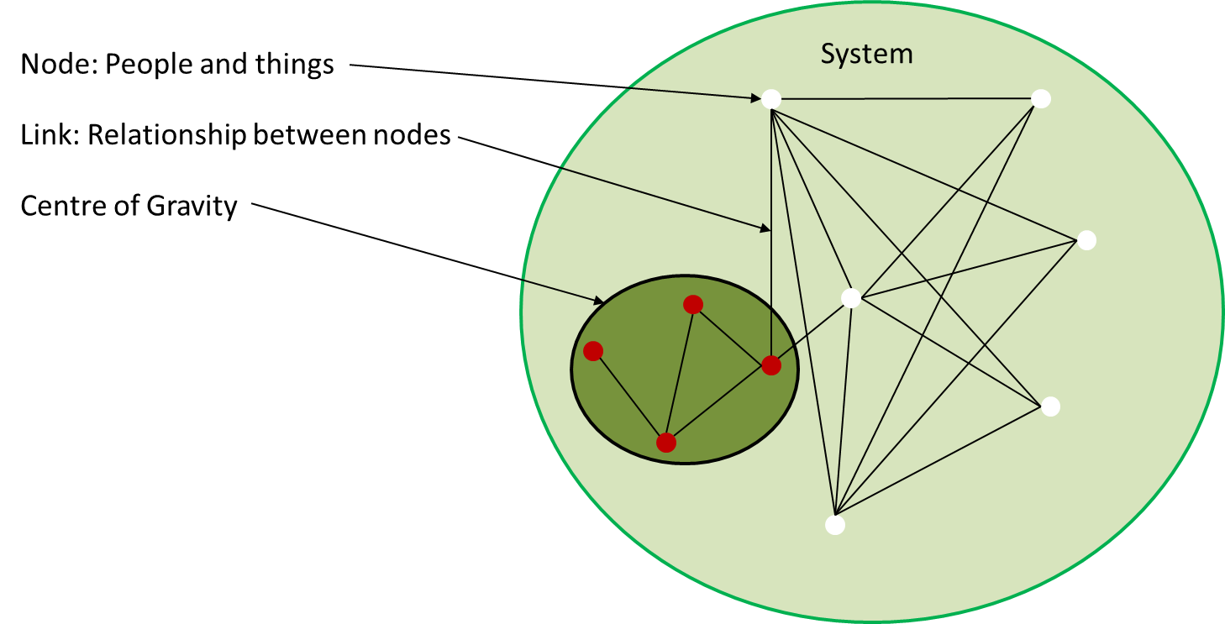

Figure Systems perspective

##### Systems Perspective

A systems perspective of the Operational Environment (see Figure 3 Systems Perspective) assists with identification of enemy COGs and their critical capabilities, requirements, and vulnerabilities. This involves knowing an enemy’s strengths and weaknesses, and how the enemy organizes, fights, and makes decisions. VIS analyzes the relevant systems in the operational environment based on understanding objectives, desired effects, and the JFC and JFACC mission, this analysis identifies a number of nodes and links. Identifying nodes and their links helps VIS assess the systems’ important capabilities and vulnerabilities and is the foundation of the systems perspective of the operational environment. This analysis identifies the interrelationship of systems and capabilities within an enemy’s COG(s) and decisive points; points for action to influence or change an adversary system behavior. A clear understanding of these relationships will help the JFACC and VIS in the identification of effective options to defeat the enemy COGs.

##### Nodes and Links.

System nodes are the tangible elements within a system that can be “targeted” for action, such as people, materiel, and facilities. Links are the behavioral or functional relationships between nodes, such as the command or supervisory arrangement that connects a superior to a subordinate, the relationship of a vehicle to a fuel source, and the ideology that connects a propagandist to a group of terrorists. Links establish the interconnectivity between nodes that allows them to function as a system — to behave in a specific way (accomplish a task or perform a function).

Thus, the purpose in targeting specific nodes is often to destroy, interrupt, or otherwise affect the relationship between them and other nodes, which ultimately influences the system as a whole. VIS link nodes to each other with sufficient detail to inform the JFACC of potential key nodes. These are nodes that might be related to a COG. Some may become decisive points for military operations since, when acted upon, they could allow the JFC/JFACC to gain a marked advantage over the enemy or contribute materially to attaining a desired effect. Key nodes are likely to be linked to, or resident in, multiple systems.

A COG typically will not be a single node in the system but will consist of a set of nodes and their respective links (relationships). For example, Figure 5, Critical Factors, shows a notional enemy’s COG consisting of nodes and links. A single node might be considered a COG as an exception, such as when the enemy’s senior military leader is also the political leader, and the nature of the adversary’s political and military systems is such that the leader’s demise would cause support for the conflict by other leaders in these systems to collapse. Also, systems can be broken down at various level. For example, one might consider an enemy’s key military capability (for example a Corps) to be a single node in the adversary’s military system, while a JFACC who must attack this capability would analyze it as a system of nodes and links in an effort to determine its critical capabilities and vulnerabilities.

##### COG Analysis.

COG analysis is important to targeting efforts because it identifies the enemy’s strengths and weaknesses, and how the adversary organizes, fights, and makes decisions. This analysis helps identify where those sources of power are vulnerable, where critical nodes within them are, and how they can be exploited.

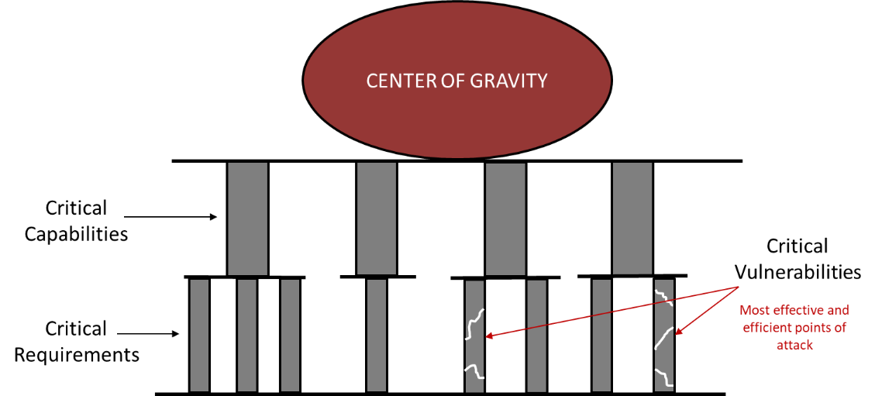

Figure COG Analysis

##### Critical Factors.

Analysis begins with the COG as a source of power. The analysis identifies the inherent abilities that allows the COG to act as such (critical capabilities - CC); identifies the essential conditions, resources, or means (critical requirements - CR) that allow the COG to operate; and then determines where those critical requirements are vulnerable (critical vulnerabilities - CV). Collectively, these are called critical factors. While it can sometimes be difficult to pick CVs from critical requirements or translate the former into explicit target sets, analysis performed during target development may help “operationalize” the targets.

Once the systems analysis is mature, the planners should then try to identify the critical factors within that system. Those elements or functions that enable the COG are its critical capabilities (CCs). Once these are identified, planners should determine the critical requirements (CRs) and critical vulnerabilities (CVs). When identifying enemy CVs, the JFACC and VIS will understandably want to focus their efforts against the CV that will do the most decisive damage to an adversary’s COG. However, in selecting those CVs, planners must also compare their criticality with their accessibility, vulnerability, redundancy, ability to recuperate, and impact on the civilian populace, then balance those factors against friendly capabilities to affect those vulnerabilities. The JFACC’s goal is to seek opportunities aggressively to apply force against an enemy in as vulnerable an aspect as possible, and in as many dimensions as possible. In other words, JFACC seeks to undermine the enemy’s strength by exploiting enemy vulnerabilities, while protecting friendly vulnerabilities from enemies attempting to do the same.

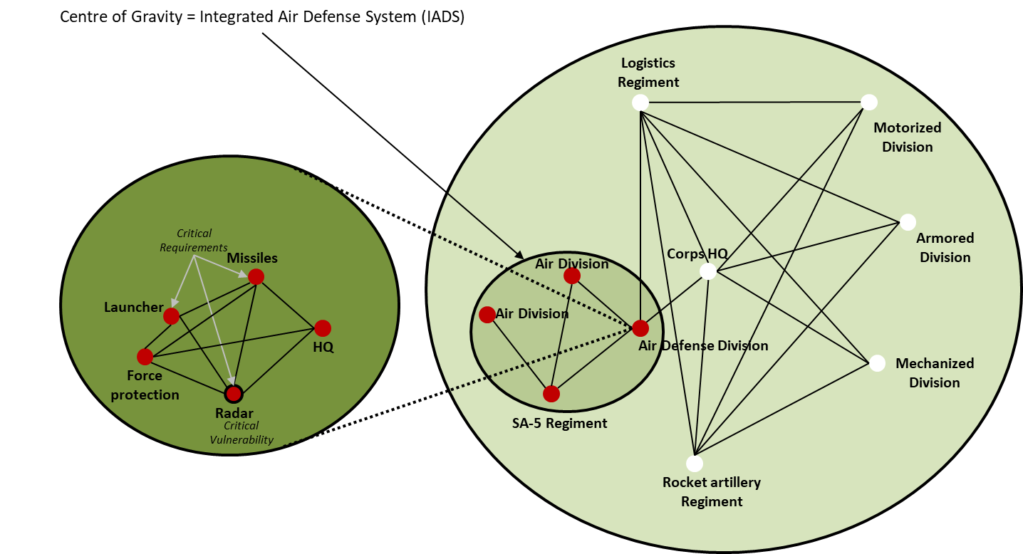

Figure 5 Critical factors

As an example, Figure 5 shows notional critical factors associated with a COG. In this example the enemy’s Integrated Air Defense System (IADS) is defined as the COG. The COG has two air divisions, one SA-5 regiment and one air defense division as the critical capabilities in the IADS. In this example we zoom in on the Air Defense division and identify that they have several nodes that all can be targeted, however only three of them are critical requirements: The missiles, the launchers, and the radar. Of these, the critical vulnerability is the radar since the system will not be able to operate without it, and the radar can be targeted by friendly anti-radiation missiles. This analysis can lead to a recommendation from VIS to JFACC to attack the enemy radars to neutralize the enemy integrated air defense system.

##### Decisive Points.

JFACC and VIS identify decisive points to help them determine where and how to apply friendly capabilities to exploit adversary vulnerabilities. A decisive point is a geographic place, specific key event, critical factor, or function that, when acted upon, allows a commander to gain a marked advantage over an enemy or contributes materially to achieving success (e.g., creating a desired effect, achieving an objective). The most important decisive points can be determined from analysis of critical factors. As part of the node-link analysis associated with a systems perspective, understanding the relationship between a COG’s critical capabilities, requirements, and vulnerabilities can illuminate direct and indirect approaches to the COG. It is likely most of these critical factors will be decisive points, which should then be further addressed in the planning process.

##### Direct Versus Indirect Approach.

The approach is the way JFACC contends with a COG; there are generally three approaches from which to choose. The decision facing JFACC is whether to attack the COG directly, indirectly, or through a combination of the two. A direct approach attacks the enemy’s COG or principal strength by applying combat power directly against it. However, COGs are generally well protected and not vulnerable to a direct approach. Thus, commanders usually choose an indirect approach. An indirect approach attacks the enemy’s COG by applying combat power against a series of decisive points that lead to the defeat of the COG while avoiding enemy strength. In theory, direct attacks against enemy COGs resulting in their neutralization or destruction provide the most direct path to victory. In the event a direct attack is not a reasonable solution, JFACC should seek an indirect approach until conditions are established that permit successful direct attacks. In this manner, the enemy’s derived vulnerabilities can offer indirect pathways to gain leverage over its COGs.

#### Study of the enemy military

After completion of the COG analysis which focus on the enemy as a system (military, infrastructure, leadership etc.), VIS will go into a more detailed study of the enemy military. VIS will first create or update available threat models such as range rings for various enemy systems and time distance measurements from various locations. VIS will then analyze the current enemy situation before analyzing the enemy capabilities and listing high value targets.

##### Threat Models

Threat models can be range rings for SAMs, artillery, rocket artillery, SCUD`s etc. Furthermore, threat models can also be time-distance from various locations (for either ground or air forces) to get an understanding of how fast an enemy unit can be at a certain location. In addition, threat models can include what distances are various enemy aircraft able to fly from their bases to get an understanding of their playtime or maximum reach. These threat models should be presented in a graphical form, using for example CombatFlite as background.

Threat models may also include A-A missile threats (DOR/MAR/Homing/what kind of countermeasures and maneuvers work best to defeat missiles), or more detailed study of enemy SAM threats (maximum altitude, range, homing, how to defeat with countermeasures or maneuvers).

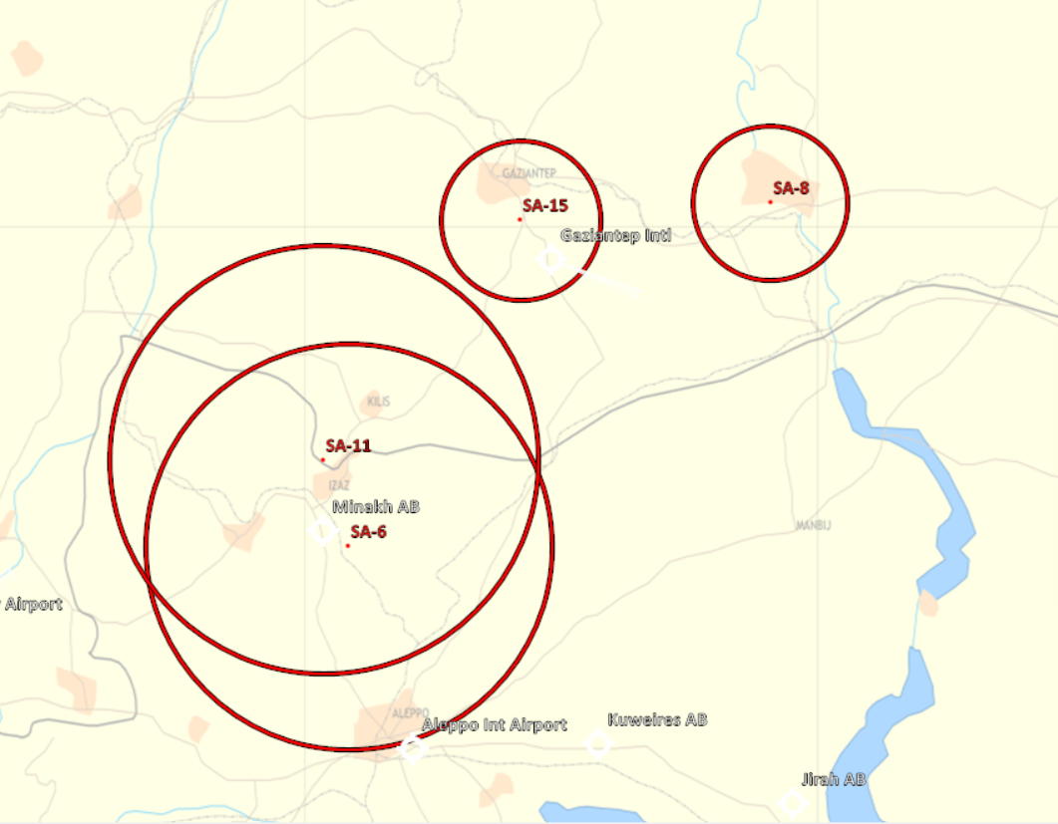

Figure 6 Example Corps Air Defense range rings

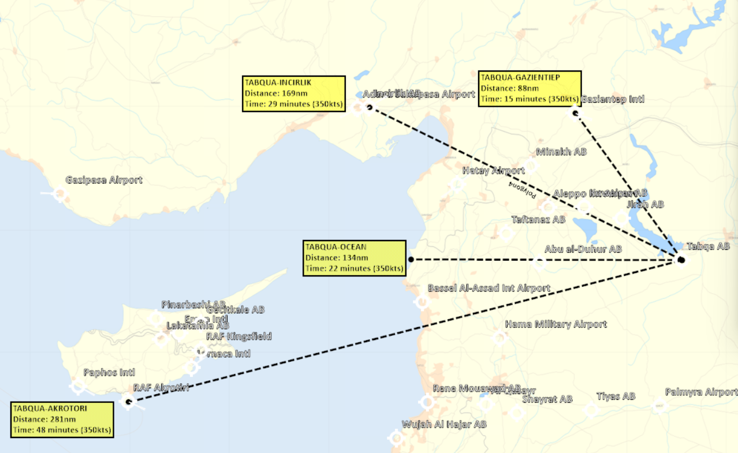

Figure 7 Example Time-distance air

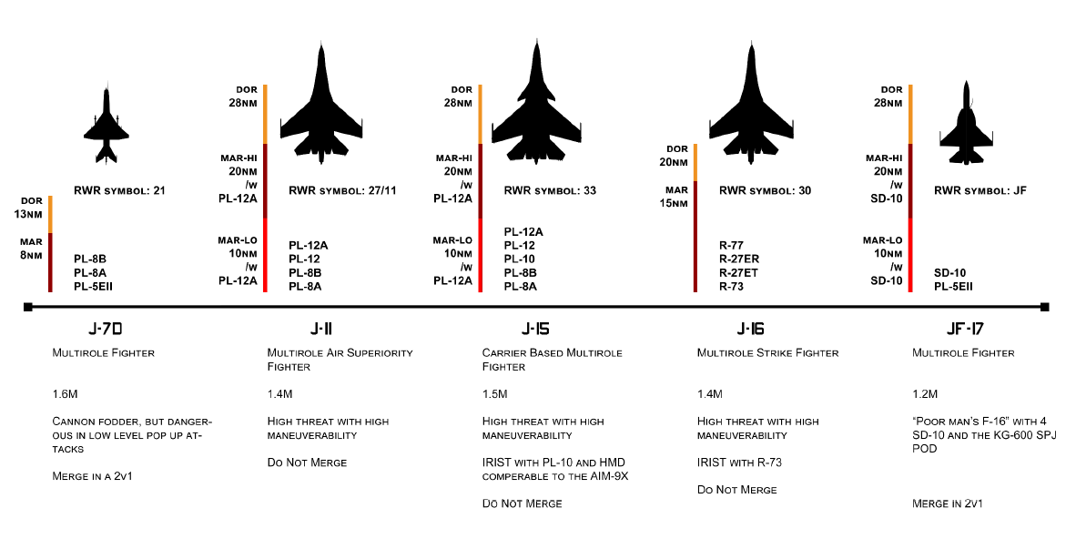

Figure 8 Example A-A Threats

##### Current Enemy Situation.

VIS determines the current enemy situation through a careful and detailed analysis of relevant order of battle (OOB) data including force strength, and disposition.

**Strength**

Strength describes a unit in terms of personnel, weapons, and equipment. Information concerning strength provides VIS/JFACC with an indication of enemy capabilities and helps determine the probable COAs or options open to the enemy. A lack of strength or a preponderance of strength has the effect of lowering or raising the estimate of the capabilities of an enemy force. Likewise, a marked concentration or build-up of units in an area gives VIS/JFACC certain indications of enemy objectives and probable COAs. Strength is determined by comparing how a threat/enemy organization is doctrinally manned and equipped with what the organization has on hand. During the campaign, accurate BDA will aid VIS in keeping track of enemy unit strength. Morale can also be affected throughout a campaign (DCS Skill level high or low) through the steady flow of supplies or a lack of supplies such as food. Morale to the troops can also be raised by visits by high-ranking generals.

**Disposition**

Disposition refers to how enemy forces are arrayed on the battlefield/battlespace. It includes the recent, current, and projected movements or locations of tactical forces. Enemy forces are generally conducting some form of offensive or defensive maneuver. Understanding how the enemy doctrinally arrays itself on the battlefield/battlespace is important in developing a good understanding the enemy here in step 3 as a foundation for step 4 (determining enemy courses of action). VIS familiarizes themselves with graphics developed during threat models that visually depict range fans with weapons’ fire limits and direct and indirect weapons capabilities to better understand enemy weapon systems.

When evaluating an enemy force, disposition refers to geographical location, tactical deployment, and movement of formations. Disposition consists of the location of enemy units and the way these units are tactically (or administratively in times of peace) deployed. In addition, disposition includes the recent, current, and proposed (or probable) movements of enemy units.

Location refers to a geographical area or position occupied by a unit or units. Knowledge of the strength and location of an enemy assists VIS in determining the capabilities of the force.

Tactical deployment is the relative position of units with respect to one another or to the terrain. Tactical formations are designed for executing the various tactical maneuvers. If this deployment can be predetermined, it leads to an accurate appraisal of intentions. The knowledge of how enemy units are echeloned may indicate (if the enemy assumes the offensive) which units will be used in the main attack and which units will be used in supporting reserve roles. Tactical deployment with respect to terrain is also important. A study of dispositions and an analysis of the terrain aid the development of conclusions concerning enemy capabilities, vulnerabilities, and intentions.

Movement of enemy units is also part of disposition. Movement is the physical relocation of a unit from one geographical point to another. Patrol activity may be an indication of planned movement. Movement is significant because it automatically changes the tactical deployment of the enemy forces.

When an enemy unit has moved, is moving, or will be moving, there are several actions which may affect the situation; for example, a unit may be moving into an attack position, or moving to reinforce or replace a unit, or perform other mission’s unknown to friendly forces. In view of these possibilities, movement of an enemy unit becomes important, and units are monitored at all times in order for the VIS to provide correct and detailed data on enemy dispositions.

##### Enemy Capabilities.

Next, VIS will then study the enemy doctrine and tactics, and supporting operations to develop a complete picture of the enemy’s capabilities and will sum up the capabilities and limitations.

VIS then combines quantitative OOB analysis with a qualitative assessment of the enemy’s readiness, training, and effectiveness to develop a complete picture of enemy capabilities. Comparing the current enemy situation with threat models highlights current strengths and weaknesses.

###### Doctrine and tactics

Doctrine and tactics include tactical doctrine as well as tactics employed by specific units. While tactical doctrine refers to the enemy’s normal organization and employment principles (given in VID Intrep’s), tactics refer to the enemy force’s conduct of operations (given in VID intrep’s and developed based on enemy action observed). Based on knowledge of an enemy’s tactical doctrine, VIS can determine how the enemy force may employ its forces in the offense and defense under various conditions. VIS will identify the enemy force’s possible actions (defend, reinforce, attack, withdraw, delay).

Understanding how the enemy force prefers to operate aids VIS/JFACC’s understanding of potential enemy COAs. TTP for enemy forces can generally be grouped in the following categories:

* Offensive tasks
* Movement to contact
* Attack
* Exploitation
* Pursuit
* Defensive tasks
* Area defense
* Mobile defense
* Retrograde

###### Supporting operations

The enemy force’s adoption of a COA will depend on the ability of its support system to support that action. However, depending on the enemy force’s objectives, possible time constraints, and/or willingness to assume risk, this could substantially alter adoption of a COA. With knowledge of these factors, VIS can better evaluate the enemy force capabilities, strength, and combat effectiveness.

The location of an enemy force’s logistical support units aids VIS in determining the disposition of maneuver formations. Logistic information critical for effective intelligence analysis includes:

* Types of supply (food, ammunition, or fuel)
* Lines Of Communications (LOCs). (Roads, rivers, railway, sea, air)
* Logistical requirements
* Distribution priorities and procedures
* Transportation networks and modes
* Installations and terminals
* Maintenance

###### Capabilities and limitations

Capabilities are the broad COAs and supporting operations that the enemy can take to achieve its goals and objectives. The following five tactical COAs are generally open to military forces in conventional operations: defend, reinforce, attack, withdraw, delay.

Each of these broad COAs can be divided into more specific COAs. An attack may be OCA Strike, envelopment, penetration, or other variations of an attack. A defensive COA can be DCA CAP, Mobile defense, or static defense. Other enemy force capabilities include support to broad COAs or specific types of operations, including:

* Deception operations.
* Cyber operations
* Intelligence operations. (Reconnaissance of targets or objectives)
* WMD employment.
* Sabotage, subversion, and terrorist operations (Using special forces).

Enemy capabilities take the form of statements, such as:

* The enemy has the ability to establish 3 CAP’s continually in the north area of operations.
* The enemy has the ability to establish QRA alert on 1 airbase 24/7.
* The enemy has the ability to conduct anti surface operations against friendly surface units (maritime).
* The enemy has the ability to insert up to two infantry battalions in a single lift operation.
* The enemy has the ability to shape the battlefield using artillery for a successful attack at city X.
* The enemy can establish a prepared defense by 14 May.
* The enemy can effectively block traffic sea traffic coming out from Crete.

When identifying threat/adversary capabilities, VIS will:

* Start with the developed threat models.
* Consider the enemy ability to conduct each operation based on all factors related to the current situation. (The enemy may be under-strength in equipment or personnel, short of logistic support, lacking air support, or the enemy’s troops may have low morale.)

##### Describe The Enemy’s Options

The study of the enemy military includes a description of the enemy’s preferred tactics.

The description:

* Lists the options available to the enemy
* Prevents the threat models from becoming more than a “snapshot in time” of the operation being depicted.
* Aids in mentally wargaming the operation over its duration and during the development of enemy COAs
* Addresses typical timelines and phases of operation, points where unit’s transition from one form of maneuver to the next and how each warfighting function contributes to the success of the operation (Command and control, maneuver, fires, logistics, intelligence).

VIS describes the actions of the supporting warfighting function in enough detail to allow for identification and development of HVTs. VIS may also examine each phase separately because target values may change from phase to phase.

###### Objectives

VIS describes and decides what goal or goals the enemy is trying to achieve.

Enemy objectives will be specific to the type of enemy, the area of operations, the unit’s composition and mission, and other factors. For example, a corps can have an objective to occupy a large area of enemy territory, while a battalion or brigade can have an objective to control a village or city. A fighter squadron can have as its objective to provide ground support to an attack, or to establish CAP or QRA. VIS also describes the enemy objective in terms of purpose and end state.

###### Time event matrix

VIS may develop a time-event matrix to describe how an enemy normally conducts specific types of operations. For example, it may be impossible to graphically depict the complex relationships between the air, naval, and ground operations of an enemy’s operation. In this case, a time event matrix could be used to show the sequencing of specific types of enemy operations and supporting operations, as well as changes in the organization, composition, and likely disposition of enemy forces during each phase of the operation (see Table 4 Time event matrix). A Time event matrix may aid VIS in identifying what targets are more important at certain times, or what indicators to look for to anticipate certain actions from the enemy.

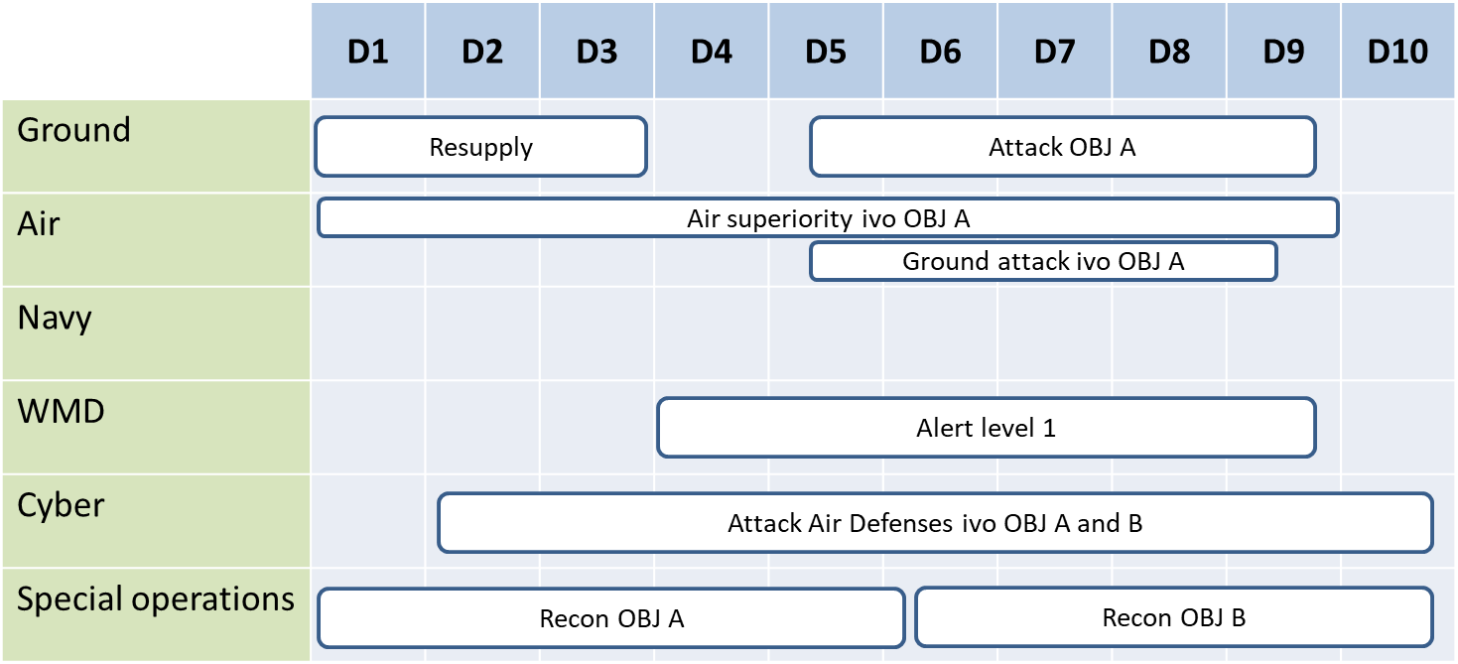

Table 4 Time event matrix

In this example the enemy ground forces are preparing to attack objective A, but before they can start their attack, they need to resupply their forces. Special operations are conducting reconnaissance of the objective, while cyber operations are trying to attack the air defenses in the vicinity of (IVO) objective A to facilitate the air operations for establishing air superiority and ground attack IVO OBJ A. Just prior to the ground attack, the WMD forces are raising its alert level to 1 in order to disperse forces to avoid being attacked in an anticipated response to the attack on OBJ A.

##### High Value targets (HVT)

The study of the enemy military should also include a list of High Value Targets (HVTs). These targets are identified by combining judgment with the evaluation of the information contained in intelligence reports and the work on the IPB so far. Assets are identified that are critical to the success of the enemy’s mission, that are key to the enemy’s supporting operation, or that are crucial to the enemy’s adoption of various variants to the operation.

For example, an enemy ground force that are attacking a heavily defended area may need artillery and rocket artillery to grind down the defenses. While doing this shaping operation the enemy is vulnerable for attacks from the air and the ability to deny attacks form the air are crucial and therefore its air defense assets are high value targets together with the necessary artillery for defeating the defending force.

Or for example, when mentally wargaming an enemy air attack against friendly targets supported by a well-prepared air defense system, it is logical to conclude that the enemy will need a substantial air defense suppression package as part of its operation to ensure the success of the attack. In this case, the artillery and air assets that form this suppression package are HVTs.

The following techniques may be useful in identifying and evaluating HVTs:

* Identify HVTs by mentally wargaming and thinking through the operation under consideration and how the enemy will use the assets to support it.
* Determine how the enemy might react to the loss of each identified HVT. Consider the enemy’s ability to substitute other assets (from another unit or a different area), or to adopt a different option.
* Evaluate and rank all HVTs according to their relative worth to the adversary’s operation (using target value analysis, see below). Also, analyze whether a target’s value depends on, or changes with, each phase of the operation.

###### Target value analysis (TVA)

HVTs should be prioritized by their relative value to the enemy’s operation. Target value analysis assists in prioritizing HVTs. Target value analysis is a process led by VIS as part of targeting that quantifies the relative value of HVTs with each other in relation to the enemy operations. This analysis is based in part on the conclusions reached by VIS upon evaluating the enemy in the study of the enemy military.

**NOTE:** While target value analysis is conducted initially during IPB in the air campaign planning, it is a separate process that is repeated throughout the execution of the air campaign as part of targeting. To be effective, this analysis depends on the most current intelligence related to the enemy. Initially, based on the understanding of the enemy developed during step 3 of IPB, target value analysis should be refined based on the enemy COAs developed during step 4 of IPB, and refined continually based on changes during operations. Whenever conducted, VIS supports target value analysis with the most up-to-date threat-related intelligence.

###### CARVER matrix

The CARVER matrix is a target value analysis tool used to identify and prioritize specific targets, so attack resources can be used efficiently (See table 5 Carver matrix). CARVER stands for criticality, accessibility, recoverability, vulnerability, effect, and recognizability.

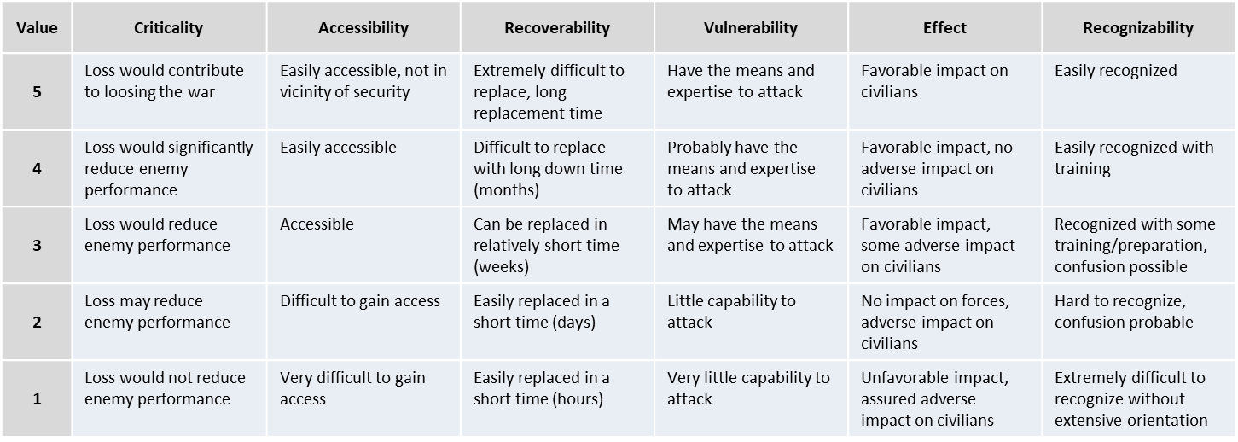

Table 5 Carver matrix

**Criticality**

Criticality means target value. This is the primary consideration in targeting. A target is critical when its destruction or damage has a significant impact on military, political, or economic operations. Targets within a system must be considered in relation to other elements of the target system. The value of a target will change as the situation develops, requiring the use of the time-sensitive methods which respond to changing situations. For example, when one has few locomotives, railroad bridges may be less critical as targets; however, safeguarding bridges may be critical to maneuvering conventional forces which require use of such bridges.

**Accessibility**

A target is accessible when an operational element can reach the target with sufficient personnel and equipment to accomplish its mission. This assessment entails identifying and studying critical paths that the operational element (aircrew or JTACs) must take to achieve its objectives and measuring those things that aid or impede access.

**Recoverability**

A target's recoverability is measured in time; that is, how long will it take to replace, repair, or bypass the destruction of or damage to the target? Recoverability varies with the sources and type of targeted components and the availability of spare parts availability.

**Vulnerability**

A target is vulnerable if the operational element has the means and expertise to successfully attack the target. When determining the vulnerability of a target, the scale of the critical component needs to be compared with the capability of the attacking element to destroy or damage it.

**Effect**

The effect of a target attack is a measure of possible military, political, economic, psychological, and sociological impacts at the target and beyond. This is closely related to the measure of target criticality. The type and magnitude of given effects desired will help planners select targets and target components for attack. Effect in this context addresses all significant effects, whether desired or not, that may result once the selected target component is attacked.

**Recognizability**

A target's recognizability is the degree to which it can be recognized by an operational element (aircrew, JTAC and controllers) under varying conditions. Weather has an obvious and significant impact on visibility. Rain, snow, and ground fog may obscure observation. Road segments with sparse vegetation and adjacent high ground provide excellent conditions for good observation. Distance, light, and season must also be considered. Table 5 show the CARVER matrix with associated values.

Example:

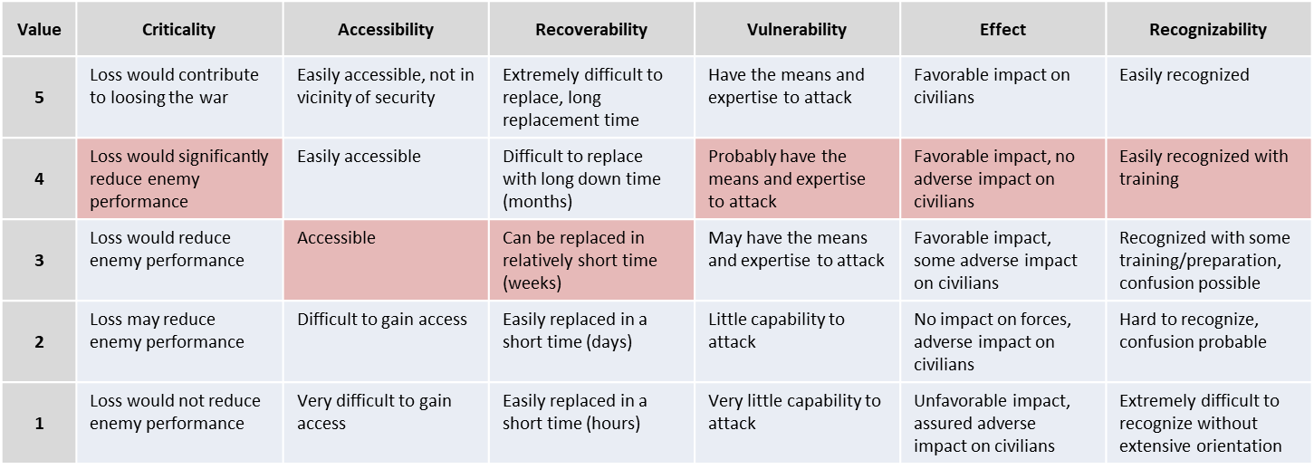

Table 6 Carver matrix example 1: MLRS

In the example above in table 6 we have a MLRS unit from the Rocket artillery regiment, which is a Corps resource. Since this is a Corps resource it is likely protected by Corps or Division Air defenses and placed outside artillery range from the FLOT. The MLRS unit in this example have a CARVER value of 22.

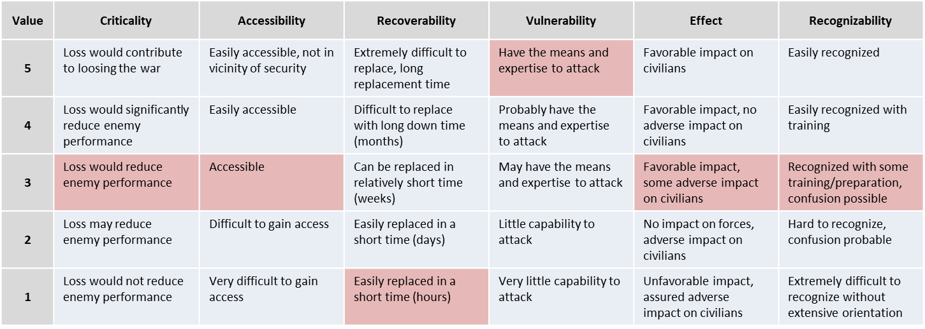

Table 7 Carver matrix example 2: Artillery

In the example above in table 7 we have a brigade artillery unit that are located close to the FLOT. Since this is a brigade resource supporting a maneuver battalion it does not have any specific defenses other than manpads. The artillery unit is located close to a civilian village. This gives a CARVER value of 18 for the artillery in this example.

#### Step Three Final Results:

1. A listing of enemy COGs.

2. Graphic threat models. Such as SAM rings, altitude distance. Aircraft A-A missile threats DOR/MAR etc. Range rings for Artillery, rocket artillery, MLRS, SCUDs.

3. A definitive and current enemy order of battle (OOB) (Ground and Air excel spreadsheet).

4. A assessment of the enemy’s current capabilities, strengths, and weaknesses.

5. A prioritized listing of High Value Targets (HVTs).

### Step Four: Determine Enemy Courses of Action.

This final step in the IPB identifies, develops, and prioritizes enemy COAs consistent with the COGs developed in step three, the enemy’s doctrine, and their assessed objectives. Step four’s purpose is to identify likely enemy COAs that can be exploited to shape the battlespace and accomplish the friendly mission and identify named areas of interest (NAI) which are used to determine which of the projected COAs the enemy has chosen. Information derived and products produced while performing steps one through three are fused together to project what the enemy is likely to do given the environment and his capabilities.

#### The Final Result of IPB—The COA Package.

Throughout the IPB process several intermediate intelligence products might be produced, which are helpful to the planning process and can be used for a myriad of other purposes. However, these earlier products are preparatory to the final result. The culmination of the IPB process yields very specific intelligence products, which are tailored to meet the needs of JFACC being supported. At a minimum, two COAs should be developed—the enemy’s most likely COA (ML COA) and the most dangerous COA (MD COA). This gives JFACC a "best estimate" and "worse case" for planning purposes. Each COA includes a description of expected enemy objectives and end states, enemy activities, the associated time and phases expected in executing the COA, expected force dispositions, associated COGs, a list of assumptions about the enemy made when projecting the COA, a list of refined HVTs, and a list of NAIs.

## Targeting

As part of the IPB process, VIS will identify a range of targets that are included or can be added to the Joint Target List (JTL). As part of air campaign planning, VIS support the targeting process by refining the Joint Target List (JTL) and include the priority (see annex 1 target priorities) on individual targets based on the effect they have on the enemy system.

### Target Analysis.

Target analysis is an examination of potential targets to determine relevance to objectives, importance, and priority of attack. Target Analysis consist of Target System Analysis (TSA) and Target Value Analysis (TVA). It is a process conducted through the VIS intelligence production process. Targeting personnel (VIS/JFACC) use these products to identify target systems and system components that can be exploited for supporting JFC/JFACC objectives. Planners use the results of target analysis throughout the campaign and in all phases of targeting to update objectives, guidance, and assessments. Target analysts look at all aspects of the target system.

#### Target System Analysis (TSA)

Target system analysis (TSA) is a process that analyses systems, networks, components, and their elements with a view to identifying the best target to effect JFC/JFACC’s requirement. TSA forms the basis of target identification and is at the very center of intelligence support to targeting. TSA aids and simplifies target selection, is crucial to BDA, helps priorities target materials production and identifies intelligence gaps. TSA identifies the relative importance of individual target system components, elements, and nodes. TSA examines:

* Specific target system functions
* Target systems’ dependencies on, and linkages to, other target systems
* The impact of exploitation of target elements on the overall system as well as on other target systems which are functionally related through those target elements.

This is conducted as a system and nodes and link analysis similar to what is done for COG’s.

The first step is identifying those target system(s) supporting enemy activity. While a single target may be significant because of its own characteristics, the target’s real importance lies in its relationship to other targets within an operational system. Target systems are usually complex, with interdependent components (see Figure 9 Target System Components and Elements) and contribute to a wide variety of activities directed toward pursuit of system goals. Examples of target systems are an enemy’s command& control structure, air defense structure, ground forces and facilities, and various form of industry (Ammunition, food, fuel).

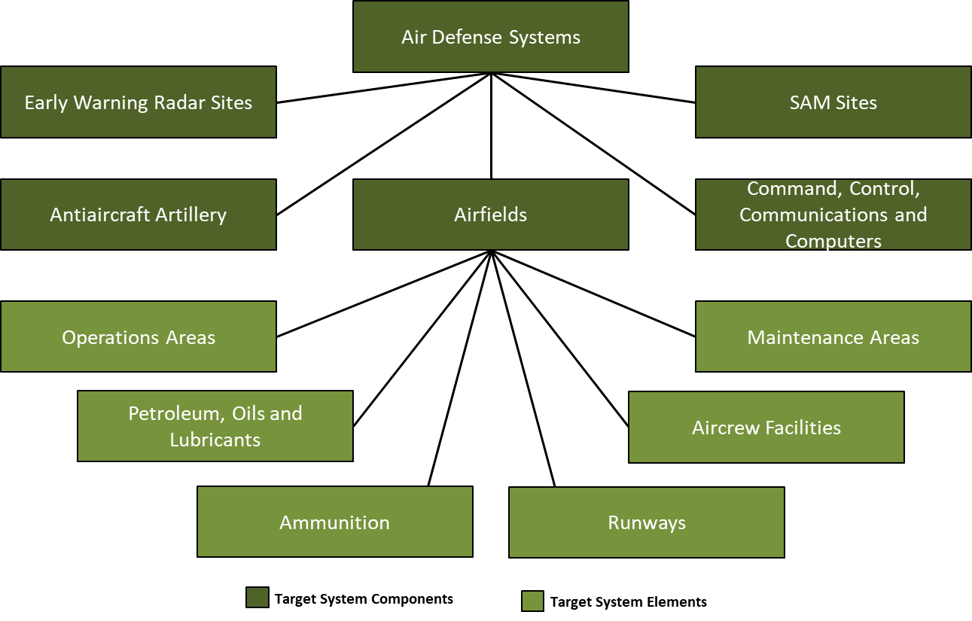

Figure 9 Target System Components and Elements

A target component is a set of targets within a target system performing a similar function. Emphasis is shifted from the system to the specific activities, such as industries and basic utilities involved in producing parts of a product. The same general analytic process applies for non-industrial target systems. For example, the components of an enemy Air Defense system might include Early Warning radar sites, antiaircraft artillery, airfields, SAM sites, and Command&Control. Each of the components can be broken down into the supporting elements (See Figure 8 above). Targeting personnel should use the target value analysis when examining the target system components and elements.

#### Target Value Analysis (TVA)

Target value analysis is a process led by VIS as part of targeting that quantifies the relative value of targets with each other in relation to the enemy operations. This analysis is based in part on the conclusions reached by VIS upon evaluating the enemy and the targets in the Target System Analysis. TVA will use the CARVER matrix to prioritize targets. See Section 3.1.3.2.5.2 Carver Matrix.

### Target validation

Validation is a part of target development that ensures all targets meet the objectives and

criteria outlined in the JFC and JFACC’s guidance and ensures compliance with the law of war and rules of engagement.

Target vetting and validation should be revisited as new intelligence becomes available or the situation changes. Target validation is done by VIS, in consultation with JFACC, as required.

Target validation asks such questions as:

* Do the targets meet Joint Force Commander (JFC)/JFACC objectives and guidance?
* Does the desired target effect support the end state?
* Is engaging the target lawful? What is the law of war and rules of engagement considerations?
* Does the target contribute to the enemy capability and will to wage war?
* Is the target (still) operational? Is it (still) a viable element of a target system? Where is the target located?
* Will striking the target arouse political or cultural “sensitivities?”
* How will striking the target affect public opinion (enemy, friendly, and neutral)?
* Are there any facilities or targets on the no-strike targets collocated with the target being validated?
* What is the relative potential for collateral damage or collateral effects, to include casualties? Consider collateral damage concerns in relation to law of war, rules of engagement, and JFC/JFACC’s guidance.
* Is it feasible to engage this target at this time? If not, could it be targeted at another time? What is the risk?
* Would engaging the target generate significant environmental impacts or arouse environmental sensitivities?
* Will engaging the target negatively affect friendly operations due to current or planned friendly exploitation of the target?
* How will actions taken against the target impact other operations?
* What is the impact of not conducting operations against the target?

### TST

Time sensitive targets (TST) are high priority targets designated by the JFC or JFACC that warrant immediate response, either because of their threat to friendly forces, or because of their highly lucrative but fleeting nature (directly supports an objective).

Some examples of potential TST could include:

* Mobile rocket launchers
* Mobile high threat surface-to-air missile systems
* Mobile command and control (C2) vehicles and facilities
* Vessels or aircraft that pose a significant threat and demand an immediate action (for example about to lay a mine field)
* Weapons of mass destruction and their supporting systems
* Fixed targets (e.g., a previously untargeted bridge that is about to be crossed by an enemy armored counterattack force rapidly becomes time-sensitive).

### Risk levels

The level of acceptable risk is critical to successful targeting during planning and execution. During execution of time sensitive targets, risk increases due to insufficient time for the more detailed coordination and deconfliction that takes place during pre-planned targeting. JFACC/VIS must assess risk early, determine what constitutes acceptable risk, and communicate their intent. Certain targets may be determined to be such a threat to the force or mission accomplishment that a higher level of risk is accepted in order to attack the target immediately upon detection. Issues for consideration in the risk assessment include:

* Risk to friendly forces (fratricide), risk to non-combatants, and collateral damage potential
* Law of armed conflict and rules of engagement compliance
* Increased risk to attacking forces due to accelerated planning and coordination
* Redundant attacks and wasting limited resources
* Non-optimal weapon selection and employment
* Opportunity cost of diverting assets from their planned missions

These considerations are balanced against the danger of not attacking the target in time and thus risking mission failure, harm to friendly forces, or losing the opportunity to strike the target. More commonly, the risk associated with dynamic targeting involves the trade-off of diverting ISR and strike assets from already scheduled missions to emerging targets. This is done when commander’s priority dictates. Planning options such as reserving on-call assets can mitigate much of this opportunity cost.

For example, if a SA-10 SAM system is placed as a time-sensitive target and there are only one SEAD flight and one CAS flight flying at that time, it might be too much risk for the flights to engage the targets alone, and for an AWACS controller, it may still be not enough assets for conducting a successful strike against the SA-10 site.

### VIS targeting output

The output of VIS targeting is an updated and validated Joint Target List (JTL) as an input for the execution of the air tasking cycle in the execution of the air campaign. VIS targeting effort also gives VIS unique subject matter expert understanding of the enemy that will aid VIS in the role as advisors for JFACC, aircrew and controllers during execution. VIS targeting also gives VIS a understanding of the enemy to provide nominations to time sensitive targets for JFACC and JFC approval.

### Air Campaign Planning Targeting Meeting

Representatives from VIS and JFACC meet to synchronize their effort prior to executing the air campaign. This can be conducted as a meeting but may also be conducted by providing the necessary information to each other by any means if time for a meeting is not possible to achieve. The Air Campaign Planning Targeting Meeting is normally only conducted once and is done prior to the detailed planning of ATO day 1 on the air campaign. However, if the campaign is very long, the meeting can also be conducted prior to each phase change in the campaign, to make sure that VIS and JFACC have a common understanding of the targeting priorities based on the situation.

The Air Campaign Planning Targeting Meeting ideally kick of JFACC air campaign planning step 4: strategy identification and is conducted after VIS is finished with the IPB.

VIS will start the targeting meeting with presenting:

* Current enemy situation (Ground, Air, Air defenses).
* Enemy Center of Gravity.
* Enemy ML/MD COA.
* Enemy HVT list.
* Intelligence Requirements (intelligence gaps).
* Recommendations for targeting in various phases
  + Big picture (not individual targets).
  + For example:
    - Recommend neutralizing enemy A-A interference by runway destruction on Airfield A, B and D at the start of the campaign as this will prevent enemy A-A Squadrons based at these airfields from taking off and taking part in combat.
    - Recommend destroying enemy long-range artillery prior to friendly ground assault in order to avoid friendly forces being engaged by artillery during their offensive.
    - Recommend destroying Corps air defenses (SA-6, SA-11, SA-15, and SA-8) by the three first days of the conflict to facilitate for AR/CAS to support Land Component Commander (LCC).
    - Recommend destroying food supplies to lower morale after initial air defenses are neutralized.
* Recommended Time Sensitive Targets (TST).

JFACC will then present the following information:

* Current friendly situation (Ground and air, including supporting assets and ordnance status. Also include what airbases aircraft will operate out from).
* Guidance from CJTF (Directions and Guidance or orders received with guidance).
* JFACC objectives.
* Anticipated air support needed for supporting LCC and MCC.
* What assets are available for targeting efforts (What kind of aircrafts, how many aircrafts for planning assumptions).

The information presented by both VIS and JFACC give everyone a good understanding of the overall enemy and friendly situation and will create the background for the following discussion about the targeting strategy and suggested phasing of the campaign.

Output of the meeting is:

* Common understanding of enemy center of gravity between VIS and JFACC
* Targeting strategy: What to target and when (target priority, “big picture”)
* Draft phasing of the campaign (what to target at what time)
* Time Sensitive Target list

# VIS Execution of the air campaign

The execution of day 1 in the air campaign cycle starts with section 4.4 Planning and direction, so for the first mission in a campaign, start at section 4.4. For all other ATO days in the campaign, the flow described below is the normal flow during the campaign (After the first ATO day). In preparation for ATO D2, VIS will start with processing and exploitation of information/intelligence from ATO D1, before producing intelligence and disseminating it to users. After dissemination VIS will start preparing for ATO D2 by doing the planning and direction step, followed by collection.

## Processing and exploitation

VIS should establish a master log of all intelligence: VIS Intelligence log. All relevant information is registered in the VIS intelligence log and is organized for further production of intelligence. Pictures (screenshots), BDA reports, observations, radar, RWR information, additional intelligence (from VID) are all registered in the log for easier use during step 2 Production. All registered items are given a reference number to keep track and avoid double reporting. In addition to the intelligence log, all entries should also be exported to a CombatFlite file if applicable. This make it easier for VIS members to see connections and how the various entries are related to each other and to enemy activity in step 2.

## Production

Production converts data into intelligence and creates the knowledge needed for the

planning and execution of operations. The intelligence must deliver knowledge, in context, in time, and in a form usable in the decision-making process. Intelligence production involves filtering, recording, evaluating, analyzing, synthesizing, and assessing all information relevant to a particular intelligence requirement (IR). During the production phase, information is:

* Evaluated to determine the reliability of the source and the credibility of the information.
* Analyzed to isolate significant elements.
* Integrated with other relevant information and previously developed intelligence.
* Interpreted to form logical conclusions and predictions that clarify the situation and support the commander’s decision-making process.
* Produced in the format most suitable to the user (JFACC, aircrew or controllers).

**Analytical Process**

VIS personnel use a framework described as screening, analysis, synthesis, and estimation. This framework calls for a disciplined approach to gathering and understanding information. The

analyst must place information in context and relate it to the current situation, planned or ongoing operations.

### Step 1: Screen Collected Information

During this step, analysts continuously filter the volume of information or intelligence received. It is during the screen phase that analysts sort information based on relevancy and how it ties to the analytical questions or hypotheses they developed in earlier steps in the intelligence cycle to fill information gaps. They do this by conducting research and accessing only the information that is relevant to their PIRs/IRs, mission, or time. Analysts also screen the volume of information based on the information source’s reliability and the information accuracy, as explained below.

|  |  |
| --- | --- |
| **Reliability** | |
|  |  |
| A | **Completely reliable**: Clearly a known source or reliable information |
| B | **Usually reliable:** A known source that provides reliable information |
| C | **Fairly reliable:** A source that has reported information with a degree of reliability |
| D | **Not usually reliable:** Typically, a source who provide information with a heavy bias, or past data was not validated |
| E | **Unreliable:** Information provided is not reliable; typically, information cannot be confirmed by any means possible with any degree of certainty |
| F | **Reliability cannot be judged**: There is no basis for estimating the reliability |
| **Accuracy** | |
| 1 | **Confirmed by other sources:** One can state with certainty there is corroborating information |
| 2 | **Probably true:** There is no actual proof, but no reason exists to assess, the source of the information is already available |
| 3 | **Possibly true:** Information may not at present be available to refute the accuracy |
| 4 | **Doubtfully true:** There is information that contradicts the accuracy |
| 5 | **Improbable:** No confirmation, and the information contradicts other reliable/accurate sources |
| 6 | **Truth cannot be judged:** Information does not meet the criteria above |

Table 1 Evaluation ratings for source reliability and information accuracy

Time permitting, analysts research by accessing information and intelligence from VIS master intelligence log, earlier intelligence reports, intelligence summaries.

This screening enables analysts to focus their efforts on only the information that is pertinent to their specific analytic problem. Analysts may decide to retain or exclude information based on results from the screen phase. While the excluded information may not be relevant to the current analytical question, the information is maintained in the VIS intelligence log as it may answer a follow-on question from a new analytical question.

As an example, a VIS volunteer working with the enemy ground forces will discard all reporting and information about enemy air activity (unless it has a direct impact on the ground forces). Or a VIS volunteer working with the enemy IADS will focus his effort on reporting about SAMs, radars and aircrafts (he may also keep information about ground forces, as the various ground forces have various SAM systems, and knowing what kind of unit operates in an area give a clear indication on what kind of SAM system to expect in that same area).

### Step 2: Analysis

Analysts must possess a knowledge of military operations, the operational environment, the friendly situation, intelligence requirements (IRs), and the enemy situation.

VIS personnel will:

* View collected information in the context of the mission, commander’s intent, and IRs.
* Identify key elements of the situation to formulate hypotheses, make deductions from those hypotheses, and reach conclusions.
* Divide the battlespace into component parts to isolate and define the elements of significant information (physical dimension, time, enemy force structure, battlespace activities, and other characteristics) to facilitate understanding and satisfy the user’s needs.
* Compare the existing situation to new information to determine whether it relates to identified IRs and to assess its impact on the current intelligence estimate.

Analysts examine relevant information or intelligence using reasoning and analytic techniques, which enable them to see information in different ways and to reveal something new or unexpected. It may be necessary to gain more information or apply a different technique, time permitting, until a conclusion is reached, or a determination is made.

Reliable and accurate information is integrated into the analytical production. Data that is less reliable or accurate is not discarded; it is retained for possible additional screening with other established information or if new requirements arise that are relevant to existing data.

### Step 3: Synthesis

Synthesis determines relationships that exist among information and pieces the information together into a coherent, meaningful picture. VIS personnel will: Identify and integrate relationships between individually significant pieces of information with the existing operational environment to provide a new picture of the situation.

As analysts reach new conclusions about the enemy activities during the analyze phase, they should corroborate and correlate this information with prior intelligence using reasoning and analytic judgement. Analysts determine how new information relates to previous analytical conclusions. New information may require analysts to alter or validate initial conclusions. Analysts must continue to evaluate and integrate reliable and accurate information relevant to their mission.

Analysts resume the analysis based on questions (hypotheses) they established during the screen and analyze phases. At this point, analysts begin to draw conclusions that translate into an initial determination that is likely to require additional analysis and, in certain instances, additional collection.

An analyst’s ultimate goal is finding enemy or threat vulnerabilities and assisting JFACC, aircrew, JTACs and controllers in exploiting those vulnerabilities. If the intelligence analysis does not answer the IR/PIR, the analyst should reexamine the guidance, consider recommending different collection strategies, and review information previously discarded as nonessential. Sometimes, the cause for not answering the requirement is the analyst’s misunderstanding of the IR/PIR or guidance, thus the analyst must return to the original question posed by JFACC and reevaluate the initial hypothesis

### Step 4: Estimation

Estimation, the bottom line of the analytical process, is based on detailed studies of the tactical situation, experience, and the supported customers intelligence needs. Estimation should describe the current conditions and present an image of future possibilities. Analysts then determine the enemy’s:

* Capabilities.
* Intent.
* Probable COAs.
* Likely reactions to friendly operations.

Well-founded estimates help manage uncertainty about the situation and facilitate planning and executing successful operations.

Analysts must properly express and explain uncertainties associated with any major analytical judgment. When briefing their analytical results, VIS personnel, should be able to assess the likelihood of an event happening, expressed by using estimative language. Phrases commonly used to convey analytical assessments and judgments, are not facts, proofs, or knowledge. Intelligence analysts use estimative language to convey their assessment of the probability or likelihood of an event

|  |  |  |  |  |  |  |  |
| --- | --- | --- | --- | --- | --- | --- | --- |
| Expressions of likelihood | Almost no chance | Highly unlikely | Unlikely | Even chance | Likely | Highly likely | Almost certain |
| Probability | 01-05% | 05-20% | 20-45% | 45-55% | 55-80% | 80-95% | 95-99% |

Table 2: Estimative language expression of likelihood

#### Expressing Confidence in Assessments

VIS may also add their confidence level on their assessments. Confidence levels express the strength of the assessment given the reasoning, methodologies, gaps, and assumptions; the number, quality, and diversity of sources; and the potential for deception.

Confidence in a judgement is based on three factors: The number of key assumptions required, the credibility and diversity of sources, and the strength of the argumentation. Each factor should be assessed independently and then in concert with the other factors to determine the confidence level. Confidence levels are ascribed using high, moderate, and low levels of confidence in analytical assessments:

* **High confidence level.** High confidence generally indicates that sound reasoning has been applied; no linchpin assumptions have been made; no critical gaps relevant to the issue are evident; consistent evidence from a variety of independent sources supports the judgment; the potential for deception is low; the body of reporting is not consistent with a plausible alternative; and/or the nature of the issue allows one to render a solid judgment. A high confidence judgment, however, is not a fact or a certainty, and such judgments still carry a risk of being inaccurate.
* **Moderate confidence level**. Moderate confidence generally indicates that potentially critical assumptions are used to fill gaps; some inconsistencies exist, but the preponderance of evidence supports the judgment; the information is credibly sourced and plausible but is not of sufficient quality or is not sufficiently corroborated to warrant high confidence; moderate potential for deception exists; and/or the body of reporting leaves open the possibility of a plausible alternative explanation of - events.
* **Low confidence level**. Low confidence generally indicates that key assumptions have been used to fill critical gaps; significant inconsistencies or questions exist regarding the evidence; the information is fragmented or uncorroborated or is of questionable credibility and/or plausibility; high potential for deception exists; and/or the body of reporting supports an alternative explanation of events.

### Production output

VIS members use all available information from last ATO day, previous events, intelligence reports and background intelligence reports and create a summary of intelligence after that ATO day. The intelligence summary may consist of:

* BDA from last ATO day
* Current enemy ground disposition (facts+assessment)
* Current enemy air disposition (facts+assessment)
* Current enemy air defense disposition (facts+assessment)
* Assessed enemy most likely course of action (ML COA) and most likely dangerous course of action (MD COA) for next 24-48 hours (next event), and more long-term (next phases)
* Recommendations
* Intelligence gaps/Intelligence requirements

In addition to the intelligence summary, VIS may produce additional intelligence reports (INTREP) on specific subjects. For example, going more into detail about capabilities, assessments on topics such as air defense, enemy air forces, enemy high value units, specific area, enemy course of actions etc.

**NOTE:** Focus is on understanding the enemy and the situation doing the analysis of available information and intelligence. The products are just a way of conveying the information. Do not feel restricted by any template or specific product. Convey the intelligence in any way suitable.

## Dissemination

Once VIS have created an intelligence summary of the last ATO day, the report is published and made available for both JFACC and all participants in the campaign in a suitable form. The intelligence and understanding of the situation and the enemy that VIS have can be either a written report or can be presented verbally at briefings. The product itself is not what is important. The product is just a way to convey the information in the most efficient way.

## Planning and direction

### Intelligence Collection

VIS intelligence effort begins with receipt of the mission and the JFC/JFACC's guidance. On-hand intelligence is rarely sufficient to support comprehensive planning and decision-making needs and gaps will remain. Such intelligence gaps are known as intelligence requirements (IR).

An intelligence requirement is any subject, general, or specific, upon which there is a need for the collection of information, or the production of intelligence. Intelligence requirements (IR) are questions about the enemy and the environment, the answers to which JFACC, aircrew or controllers requires to make sound decisions. The breadth of potential intelligence gaps, however, will generally far exceed intelligence capabilities available. Thus, it is important to focus intelligence operations on those intelligence requirements crucial to mission success. We call these requirements priority intelligence requirements (PIR) (This does not mean that only PIR can be collected on. Both PIR and IRs can be collected on and used for production of intelligence).

Generally, the difference between a PIR and an IR is that JFACC must have the answer to the PIR to make a decision. At any one time there are not many PIRs in effect. PIRs are prioritized among themselves and may change in priority over the course of an evolution. It is JFACC who designates the priority intelligence requirements (based on recommendations or nominations from VIS) and therefore provides direction to the intelligence effort.

The lowest priority PIR takes precedence over the highest priority IR. IRs are questions typically generated by JFACC, VIS, aircrew, JTACs or controllers but not ones that JFACC feels they needs answered before making decisions. While there are ideally a few PIRs, there may be many IRs. Like PIRs, IRs should be prioritized against each other to support effective intelligence planning and operations. PIRs and IRs have the following characteristics.

Each PIR or IR:

* Asks only one question.
* Focuses on specific facts, events or activities concerning the enemy or the battlespace.
* Is tied to mission planning, decision-making, or execution.
* Provides a clear, concise statement of what intelligence is required.
* Contains geographic and time elements to limit the scope of the requirement.

Example PIR

* Will Russian military forces intervene in Syria on D5?
* How will Russian military forces intervene in Syria in phase 2?
* What are Syrian air defense posture ivo Damascus in phase 3?
* Where are Syrian SCUDs located on D4?
* Where are Syrian rocket artillery located at the start of phase 1?

Example IR

* Are Syrian SA-11 still operational IVO Tabqua on D3?
* Are Russian SU-34 based on Bassel Al Assad in phase 2?
* What are Syrian air defense posture ivo Jirah in phase 3?
* What is the status of Syrian QRA on D3?

For VIS, any RFI from JFACC, aircrew, JTACs or controllers are an IR (or should be converted into an IR).

VIS may create Named Areas of Interest (NAI) that will aid in the collection of information

Named Areas of Interest are the geographical area where information that will satisfy a specific information requirement can be collected. Named areas of interest are usually selected to capture indications of adversary courses of action but also may be related to conditions of the enemy or the battlespace.

The first thing VIS will do with their prioritized list of IR/PIRs are to develop indicators that may aid in answering the question. Some IR/PIRs only have one or a few indicators, while other IR/PIRs are very complex and have many indicators. The indicators and answer to these will aid in the production of intelligence while answering the IR/PIR. See example of indicators below.

Example IR with indicators

* Are Syrian SA-11 still operational IVO Tabqua on D3?
  + Are SA-11 vehicles seen IVO Tabqua?
  + Are SA-11 radar transmission reported ivo Tabqua
  + Are SA-11 vehicles seen or reported leaving Tabqua?
* Are Russian SU-34 based on Bassel Al Assad in phase 2?
  + Are there air tracks that have terminated at Bassel Al Assad?
  + Are SU-34 reported ivo Syria?
  + Where are SU-34 aircraft originating?
  + What is the current composition of aircraft on Bassel Al Assad?
  + Is there Russian presence on Bassel Al Assad?
  + What kind of Russian activity are reported on Bassel Al Assad in phase 1?
* What are Syrian air defense posture ivo Jirah in phase 3?
  + What SAM units are located ivo Jirah?
  + What AAA units are located ivo Jirah?
  + What radar activity are reported ivo Jirah?
  + What aircrafts are currently based at Jirah?
* What is the status of Syrian QRA on D3?
  + What are the times from detection to launch for Syrian QRA at Tabqa?
  + What are the times from detection to launch for Syrian QRA at Jirah?
  + What aircrafts are used as QRA aircrafts?
  + What kind of weapons are the QRA aircrafts using?
  + Do the QRA aircraft have external fuel tanks?
  + What are the QRA aircraft tactics once airborne?
  + From what airbases were Syrian aircraft launched on D1 and D2?

When VIS have a prioritized list of IRs and PIR’s with indicators, VIS will make a decision for each IR/PIR if they belong in one of the following three categories:

* Production
  + This means that VIS have enough information about this IR/PIR to start producing intelligence to answer the IR/PIR. Follow steps as outlined in section 4.2
* Collection
  + VIS do not have sufficient information about this IR/PIR to start producing intelligence, but by using JFACC assets (aircrew or controllers) they can collect more information in subsequent ATO days to get information to answer the IR/PIR later.
* RFI
  + VIS do not have sufficient information about this IR/PIR to start producing intelligence and JFACC assets are likely not able to collect relevant information to answer the IR/PIR. VIS will then submit an RFI to VID for additional information that may help contribute to answering the IR/PIR later.

**Collection**

For IR/PIRs that are categorized as for collection VIS will ensure they have indicators that are observable/reportable so that aircrew and controllers are able to answer them during the flight. Indicators are given a number tied to the IR/PIR so that pilots can answer the correct indicator, and that it will make it easier for VIS to collect the information and make sense of it during intelligence collection. For example, if IRs are labelled with numbers 1-10, then indicators can be given as X.1, X.2 etc. Example:

* IR 1: What is the status of Syrian QRA on D3?
  + - 1.1: What are the times from detection to launch for Syrian QRA at Tabqa?
    - 1.2: What are the times from detection to launch for Syrian QRA at Jirah?
    - 1.3: What aircrafts are used as QRA aircrafts?
    - 1.4: What kind of weapons are the QRA aircrafts using?
    - 1.5: Do the QRA aircraft have external fuel tanks?
    - 1.6: What are the QRA aircraft tactics once airborne?

Having multiple assets answer the same IR/PIR (either the same indicators or different indicators) provides VIS with the best possible information to be able to answer the IR/PIR during production of intelligence as this will give different perspectives.

VIS will inform JFACC about the IRs they have listed for collection as an input to the targeting meeting. After the targeting meeting, JFACC will use the inputs and give order in the ATO for relevant flights to collect on the indicators listed. If required JFACC may also task flights with intelligence collection as the mission for the flight.

It is important for VIS and JFACC to not overload aircrew and controllers with IR/PIRs with many indicators if the flight is tasked with doing something else. As a rule of thumb, all flights should have at least a few indicators that they should answer after the flight. If a flight is dedicated for collecting intelligence, the aircrew/controllers may have a longer list of IR/PIR and indicators for that specific flight.

The various indicators do not necessarily work for everyone, and VIS and JFACC should ensure that they give the task to collect on the right indicator to an asset that is suited for answering the questions. See example below:

* IR 1: What is the status of Syrian QRA on D3?
  + 1.1: What are the times from detection to launch for Syrian QRA at Tabqa?
    - AWACS Controller
  + 1.2: What are the times from detection to launch for Syrian QRA at Jirah?
    - AWACS Controller
  + 1.3: What aircrafts are used as QRA aircrafts?
    - Aircrew
  + 1.4: What kind of weapons are the QRA aircrafts using?
    - Aircrew
  + 1.5: Do the QRA aircraft have external fuel tanks?
    - Aircrew
  + 1.6: What are the QRA aircraft tactics once airborne?
    - AWACS controller and aircrew

### Targeting

VIS support targeting effort with maintaining BDA and updated status of the JTL. See Section 2.2  and Section 3.2 for additional information about targeting

### Targeting meeting

Representatives from VIS and JFACC may meet to synchronize their effort prior to the next ATO day. This can be conducted as a meeting but may also be conducted by providing the necessary information if time for a meeting is not possible. The targeting meeting can be conducted for each ATO day, or for any interval JFACC and VIS deem necessary (For example every other ATO day, or once for every phase). Ideally the targeting meeting start JFACCs stage 2 (Targeting, weaponeering, MAAP and AOD) in the Air Tasking Cycle.

VIS will start the targeting meeting with presenting:

* Weather (forecast for next period)
* Current enemy situation (Ground, Air, IADS)
* BDA last ATO
* Enemy ML/MD COA next ATOs (24-72 hours out) (Any changes to already briefed ML/MD COA)
* Current TST list
* Intelligence Requirements (intelligence gaps)
* Any recommendations for targeting

JFACC will then present the following information:

* Current friendly situation (Ground and air, including supporting assets and ordnance status) and planned operations next period.
* New guidance from JFC (Directions and Guidance or orders received with guidance)
* Air requests from Land Component Commander (LCC or Maritime Component Commander (MCC).
* What assets are available for next ATO day (to be tasked with targeting)

The information presented by both VIS and JFACC give everyone a good understanding of the enemy and friendly situation. The next item to be presented are JFACC and VIS nominations to the Joint Prioritized Target List for the next ATO. After the nominations VIS and JFACC will discuss and agree on a prioritized list of the targets. If there are any discrepancies, JFACC will have the final word. This will be the approved JPTL for next ATO cycle.

JFACC and VIS will also present and suggest a draft JPTL for the subsequent ATO cycles so both VIS and JFACC know what the likely priorities on the subsequent ATO cycles are, as this also may drive intelligence collection efforts.

Finally, VIS and JFACC validate the time sensitive target list (make sure to add new TSTs if required or remove TSTs if applicable).

## Collection

During ATO execution VIS will have no active role for the collection. This will be handled by aircrew, JTACs and AWACS controllers.

# Chapter 3: 132nd Flow

In the 132nd hosted campaign, the workflow for VIS is divided into two major parts. Part 1 is conducted prior to the first campaign mission and support JFACC’s air campaign planning. The primary effort for VIS in part 1 is the Intelligence Preparation of the Battlefield, and the supporting effort of targeting that comes out if that process. The output of the VIS effort during part 1 is the IPB package (ML/MD COA, HVT list, various intelligence reports) and the Joint Target List (JTL).

Part 2 is part of the execution of the air campaign and VIS primary effort is to follow the intelligence cycle with processing information from last event, producing intelligence, make the intelligence available, plan and direct intelligence operations for next event.

**CAUTION:**

It is very easy to get too focused on products and creating the “correct” products and documents. The most important thing for VIS is to make a best effort to have the best possible understanding of the enemy and the situation.

**NOTE:**

No one expects intelligence to be 100% accurate. There is uncertainty, conflicting information, inaccurate reporting, lack of reporting. VIS use their best judgement based on the facts and information available to provide the most accurate picture of the situation.

**NOTE:**

Real life will likely always prevent everyone from being committed 100% to the entire process every time. That is not a problem, and everyone should be prepared to be flexible and make decisions or have products that are not 100%, respecting that this is a hobby for everyone and understand that people may have limited time to support from time to time.

## Part 1 Planning: Air Campaign planning

The goal for VIS Air Campaign planning is to provide JFACC with the necessary understanding and situational awareness (SA) on the enemy and the situation for JFACCs planning of the air campaign. VIS supports JFACCs air campaign planning using the VIS Intelligence Preparations of the Battlespace (IPB) process that consist of four steps:

Step 1: Define the Operational Environment

Step 2: Describe the Operational Environment`s Effects

Step 3: Evaluate the Enemy

Step 4: Determine Enemy Course of Actions (COA)

VIS may start planning at the same time as JFACC, or VIS may start earlier than JFACC in planning. The VIS IPB process is connected to JFACC Air Campaign planning in the following way:

* VIS IPB Step 1 and 2 are an input to JFACC Air Campaign Planning step 1 (Operational Environment Research).
* VIS IPB Step 1-3 are inputs to JFACC Air Campaign Planning step 2 (Center of Gravity Identification).
* VIS IPB step 1-4 are inputs to JFACC Air Campaign Planning step 3 (Objective Determination) and step 4 (Strategy identification).

**There are a lot of work and time-consuming tasks in the Intelligence Preparations of the Battlespace (IPB). However, it will pay dividends when it is completed before the start of the air tasking cycle. The workload is reduced between each planned event and events can be conducted at a higher pace as VIS have a deeper understanding of the enemy and the battlespace.**

During the various steps, intelligence reports can be produced on specific topics (For example threat from enemy a-a missiles such as MAR distances and homing and most effective countermeasures or maneuvers, threat from enemy aircrafts, threat from enemy SAMs). This are basic intelligence based on the equipment and any available information (VID INTREP Generic ground force structure and VID INTREP generic air force structure) adjusted for the current campaign so JFACC and participants in the campaign better understand the threats they are facing.

### Step 1: Define the Operational Environment

In step 1 VIS decide what areas they should focus on (which countries and how far out to sea). Typically, this will be the enemy country, and neighboring countries in addition to any potential alliance partners. This area will be defined as the area of intelligence interest (AII).

### Step 2: Describe the Operational Environment`s Effects

In this step VIS will study the enemy order of battle (OOB), the terrain. Input to this step is VID INTREP`s provided for the situation/campaign and VID basic intelligence (INTREP VID B-001 Generic Ground Force Structure and INTREP VID B-002 Generic Air Force Structure).

VIS will start with determining the current enemy situation through an analysis of relevant order of battle inputs in VID INTREP`s and basic intelligence. How are the enemy forces positioned in the AOR is one of the key answers that come out of this sub-step. Another output is the definitive and current Enemy order of battle (for example in a spreadsheet) for updating and keeping track of BDA of the enemy forces (and what remaining forces are still left in the area of operations) during the execution phase of the campaign.

In this step VIS will also look at the map (using CombatFlite) on the AOR/AII and look at important features that will aid in subsequent steps:

* Time and distance (from various airbases, at different speeds)
* Time and distance (from bases or major cities following major roads)
* Identify blind zones (for enemy SAM/EW radars). A detailed study of the terrain to see opportunity and limitations.
* Identify mobility corridors for enemy ground forces
* Identify sea lines of communications (seaports)
* Identify key terrain that may be important for the enemy or friendly forces

### Step 3: Evaluate the Enemy

In this step VIS will evaluate and analyze the enemy. Input to this step is VID INTREP`s provided for the situation/campaign and VID basic intelligence (INTREP VID B-001 Generic Ground Force Structure and INTREP VID B-002 Generic Air Force Structure).

VIS will start with analyzing and identifying the enemy’s center of gravity (COG).

VIS will then create or update available threat models. This can be range rings for SAMs, artillery, rocket artillery, SCUD`s etc. In addition, this can be what distances are various enemy aircraft able to fly from their bases (playtime), what the A-A missile threats are (DOR/MAR/Homing/what kind of countermeasures and maneuvers work best to defeat missiles). These threat models should be presented in a graphical form, using for example CombatFlite as background.

VIS will then combine the information and provide an assessment of the enemy’s current capabilities, strengths, and weaknesses. In addition, VIS will identify enemy high value targets (HVT) and list the priority of these.

### Step 4: Determine Enemy Course of Actions (COA)

In this step VIS will identify and develop the enemy most likely and most dangerous course of action (ML/MD COA). The purpose is to identify the enemy COAs so they can be exploited to accomplish the friendly mission. Information derived and products produced while performing steps one through three are fused together to project what the enemy is likely to do given the environment and his capabilities.

VIS will also identify high value targets (HVT) and other targets that are valuable to the enemy in executing the COAs and nominate for attack those targets that will achieve the chosen friendly COA and objectives.

VIS will identify any collection requirements that monitor indicators that can inform VIS on which COA the enemy are using (or if there will be a shift from one COA to another COA).

Once step 4 is completed, the outputs from all steps can be combined into one report that will aid JFACC in their planning of the air campaign. Intelligence from the various steps will also aid VIS and JFACC in the execution phase of the campaign.

### The Air Campaign Planning Targeting Meeting

With IPB complete, VIS and JFACC meet to conduct the Air Campaign Planning Targeting Meeting. This meeting ideally kicks off JFACC’s step 4 in the air campaign planning. See section 3.2.6 for more information about the Air Campaign Planning Targeting Meeting

## Part 2 Execution: Air Tasking Cycle (per ATO day)

Throughout the process VIS members follow overall guidance and priorities given by JFACC in JAOP and AOD.

### Per event

After an 132nd event VIS follow the intelligence cycle in the steps listed below. Step 1-3 focus on the previous ATO day, while step 4-5 focuses on the next ATO day.

#### Step 1 Processing:

All relevant information is registered in the VIS intelligence log and is organized for further production of intelligence. Pictures (screenshots), BDA report, observations, radar, RWR information, additional intelligence (VID) are all registered in the log for easier use during step 2 Production. All registered items are given a reference number to keep track and avoid double reporting. In addition to the intelligence log, all entries are also exported to a CombatFlite file. This make it easier for VIS members to see connections and how the various entries are related to each other and to enemy activity in step 2.

#### Step 2 Analysis and Production

VIS members use all available information from last ATO day, previous events, intelligence reports and background intelligence reports and create a summary of intelligence after that ATO day. The intelligence summary may consist of:

* BDA from last ATO day
* Current enemy ground disposition (facts+assessment)
* Current enemy air disposition (facts+assessment)
* Current enemy air defense disposition (facts+assessment)
* Assessed enemy most likely course of action (ML COA) and most likely dangerous course of action (MD COA) for next 24-48 hours (next event), and more long-term (next phases)
* Recommendations
* Intelligence gaps/Intelligence requirements

In addition to the intelligence summary, VIS may produce additional intelligence reports (INTREP) on specific subjects. For example, going more into detail about capabilities, assessments on topics such as air defense, enemy air forces, enemy high value units, specific area, enemy course of actions etc.

NOTE: Focus is on understanding the enemy and the situation doing the analysis of available information and intelligence. The products are just a way of conveying the information. **Do not feel restricted by any template or specific product. Convey the intelligence in any way suitable.**

#### Step 3 Dissemination

Once VIS have created an intelligence summary of the last ATO day, the report is published and made available for both JFACC and all participants in the campaign in a suitable form. The intelligence and understanding of the situation and the enemy that VIS have can be either a written report or can be presented verbally at briefings. The product itself is not what is important. The product is just a way to convey the information in the most efficient way.

#### Step 4 Planning and direction

As a preparation for the next event, VIS members look at overall guidance in JAOP and AOD and look at their current intelligence gaps and based on this identify intelligence requirements that are presented to JFACC. JFACC will include these intelligence requirements into their air tasking cycle (stage 2) and if prioritized flights will be tasked to collect information to answer the intelligence requirements. The intelligence gaps can also be forwarded to VID (mission designer) as a request for information (RFI).

With all intelligence produced and disseminated during step 3 and 4 VIS have the necessary intelligence and SA to support JFACC for the next event. During this step VIS and JFACC therefore may conduct a “targeting meeting”.

##### Targeting meeting

Representatives from VIS and JFACC meet to synchronize their effort prior to the next event. This can be conducted as a meeting but may also be conducted by providing the necessary information if time for a meeting is not possible. The targeting meeting can be conducted for each ATO day, or for any interval JFACC and VIS deem necessary (For example every other ATO day, or once for every phase). Ideally the targeting meeting start JFACCs stage 2 in the Air Tasking Cycle.

See section 4.4.3 for detailed information about Targeting meeting.

#### Step 5 Collection

In step 5, VIS have no active role.

During the next ATO day, participants collect necessary information based on the intelligence requirements

### Special topics

VIS may also work independently of the air tasking cycle if working on special topics such as: “*Will state X intervene in the conflict, and if so, when and how will they intervene*” or “*What is the status of state X chemical weapon program*”. All intelligence gaps and collection should be tied into the air tasking cycle, but the reports may be presented only once in the campaign either before a phase change, or when it is needed to answer important intelligence gaps for JFACC before deciding what to do.

When working with special topics, VIS members follow the same intelligence steps as listed in the air tasking cycle but will typically start with planning and direction before collection is done. Once VIS have received enough information VIS then process the information before analyzing the data and producing intelligence. The cycle can then be repeated how many times as necessary until VIS have enough for a product (either verbally or written) that can be disseminated.

# VIS organization

Best practice for organizing VIS is:

## Air campaign planning

It is recommended that one member of the VIS team is in charge, as it will be easier to maintain overall understanding and making sure the entire team gets through the process. To get a through and good understanding of the enemy and the situation it is recommended that all VIS members conduct the steps in the IPB without breaking out in various teams. This will give the best overall understanding that will aid during the air tasking cycle.

## Air tasking cycle:

For the execution of the campaign through the air tasking cycle it is recommended that VIS members organize themselves in teams (based on interest and who people like to work with)

It is recommended that various VIS members organize themselves in teams:

* Air/Air defense (IADS)
  + This team will focus on the enemy’s air forces, their SAM systems or IADS. This team may keep an updated orbat and BDA over enemy air assets and the status of IADS
  + There is a potential overlap with the team working with the ground picture, as the enemy ground forces also have SAMs in their orbat. But these are systems primarily supporting the enemy’s ground forces so there may be need for some coordination with the ground team on who is responsible for the SAMs
  + This team is typically supporting pilots/controllers in OCA/DCA/SEAD operations, while also support Air Interdiction and Long-Range strikes.
  + This team also function as a subject matter expert for JFACC on enemy Air and Air defense.
* Ground (Enemy ground forces)
  + This team will focus on the enemy’s ground forces, their position and activity
  + This team will try to identify locations for enemy high value targets such as headquarters, artillery, logistics
  + This team will try to anticipate what the ground forces will be doing in the future
  + This team is typically supporting pilots/controllers in CAS/AR missions
  + This team also function as a subject matter expert for JFACC on enemy ground forces.
* Targeting/Overall scenario
  + This team will focus on the “big picture” and keep track of other countries and what they are doing
  + This team also focuses on the campaign and its objectives, and is thus the best suited to focus on the air interdiction campaign and the targeting for the overall campaign
  + This team also try to keep track of the enemy ML and MD COA and can give recommendation if the enemy switch from a ML to a MD COA so JFACC can make necessary changes.
  + This team is typically mostly focused on supporting JFACC.
  + Ideally the person leading the VIS effort is part of this team.

# ANNEX

## Annex 1: Target priorities

Priority A

* The target is essential for mission success in support of current objectives (or is a designated a Time Sensitive Target (TST).
* It is crucial to the overall success of the operation.
* It will have immediate and compelling effects.
* Its timeliness as an urgent target may not exist in the future.
* If not targeted, negative consequences may seriously jeopardize future CJTF operations

Priority B:

* Targets have substantial, but not immediate impact on the battle.
* The cascading effects this target provides may not be realized in the future.
* If not targeted on this ATO, a significant level of effort may be required later.
* If not targeted, negative consequences may significantly hamper CJTF operations.

Priority C:

* It will contribute to the battle, but it is not critical to mission success.
* It will further the success of the operation.
* It will eventually require targeting due to JFC future plans.
* If not targeted on this ATO, negative consequences will probably not impede operations.

Priority D:

* Target of opportunity if:
  + A) Other targets not suitable for this ATO.
  + B) As a backup target
* It will have minor contributions to the operation.
* It may be required for targeting but is not time critical.
* If not targeted, no negative consequences

## ANNEX X: Intelligence production – Ground

WIP

## ANNEX X: Intelligence production – Air

WIP

## ANNEX X: Intelligence production – Targeting

WIP

## ANNEX X: Intelligence production – Big picture

WIP

## Abbreviations

**AA**: Avenues of approach

**AADC:** Area Air Defense Commander

**ACA:** Airspace Control Authority

**ACP:** Airspace Control Plan

**ACO:** Airspace Control Order

**AII:** Area of Intelligence Interest

**AI:** Air Interdiction

**AOR:** Area of Responsibility

**AO:** Area of Operations

**AR:** Armed Reconnaissance

**AOD:** Air Operations Directive

**ATO:** Air Tasking Order

**BDA:** Battle Damage Assessment

**CARVER:** Criticality, accessibility, Recoverability, Vulnerability, Effect, Recognizability

**CAS:** Close air Support

**CJTF:** Combined Joint Task Force

**COG:** Center Of Gravity

**CC:** Critical Component

**CR:** Critical Requirement

**CV:** Critical Vulnerability

**COA:** Course Of Action

**CONOP:** Concept of Operations

**DOR:** Desired Out Range

**HVT**: High Value Target

**IADS:** Integrated Air Defense System

**IPB:** Intelligence Preperation of the Battlefield

**IR:** Intelligence Requirement

**IVO:** In vicinity Of

**INTREP:** Intelligence Report

**INTSUM:** Intelligence Summary

**JAOP:** Joint Air Operations Plan

**JFACC:** Joint Force Air Component Commander

**JFC:** Joint Force Commander

**JPTL:** Joint Prioritized Target List

**JTL:** Joint Target List

**JTF:** Joint Task Force

**LCC:** Land Component Commander

**LLOC:** Land Lines Of Communcations

**LOC:** Lines of Communication

**MAR:** Minimum Abort Range

**MCC:** Maritime Component Commander

**MCOO:** Modified Combined Obstacles Overlay

**MD COA:** Most Dangerous Course of Action

**ML COA:** Most Likely Course of Action

**NAI:** Named Area of Interest

**OE:** Operational Environment

**OOB:** Order Of Battle

**PIR:** Priority Intelligence Requirement

**RFI**: Request For Information

**SA:** Situational Awareness

**SOCC:** Special Operations Component Commander

**SLOC:** Sea Lines Of Communications

**SPINS:** Special Instructions

**TAI:** Target Area of Interest

**TSA:** Target System Analysis

**TVA:** Target Value Analysis

**TTP**: Tactics, Techniques and Procedures

**VID:** Virtual Intelligence Directorate

**VIS:** Virtual Intelligence Service

**WMD:** Weapons of Mass Destruction